Recycling Carbon Fiber: Cutting Process and Device

By

Misha Minasyan
Project Partner: Jason Morrow

Table of Contents
1: INTRODUCTION 4
1a: Description: 4
1b: Motivation: 4
1c: Function Statement: 4
1d: Requirements: 5
1e: Engineering Merit: 5
1g: Success Criteria: 5
2. DESIGN & ANALYSIS 5
Proposed Solution 6
Analysis 6
Energy Experiment 6
Analysis from Experiment 7
Performance Prediction and Scope 8
3. METHODS & CONSTRUCTION 8
Refer to renderings 9
Device Operation 9
Benchmark Comparison: 9
Performance Predictions: 9
4. TESTING METHOD 9
Test Plan: 10
Test Documentation and Deliverables 10
BUDGET/SCHEDULE/PROJECT MANAGEMENT 10
Budget 10
Schedule 10
Project Management 11
Risk Analysis 11
DISCUSSION 11
CONCLUSION 12
ACKNOWLEDGEMENTS 12
APPENDIX A – Analyses 13
A.1 Gear Properties 13
A.2 Housing Requirements: 14
A.3 Bending Stress Calculation: 15
A.4 Kinetic Energy Calculation: 16
A.5 Scaling the Kinetic Energy 17
A.6 Minimum Diameter 18
A.7 RPM Requirement 19
A.8 Second Minimum Diameter Calculation 20
A.9 Key Calculation for Cutting 21
A.10 Key Calculation for Motor 22
A.11 Diameter for Pins Connecting Housing 23
A.12 Shear Stress in Shaft 24
A.13 Chain Spreadsheet Calculation 25
A.14 Gear Spreadsheet Calculation 26
A.14 Gear Spreadsheet Calculation Continued 27
APPENDIX B – Sketches, Assembly drawings, Sub-assembly drawings, Part drawings 29
Assembly.1 First Version of Assembly 29
B.1 Drawing Tree 30
B.2 Electric Motor 31
B.3 Chain 32
B.3 Connecting link for Chain 33
B.4 Shaft for Blades 34
B.5 Sprocket Small 35
B.6 Key 36
B.7 Cover Plate 2 37
B.8 Gear 1 38
B.9 Top Plate – ASME Y14.5 39
B.10 Sample Blade 40
B.11 Sprocket 1 41
B.12 Side Plate 42
B.13 Bolts 43
B.14 Bearing 44
B.15 Keyway 2 45
APPENDIX C – Parts List and Costs 46
APPENDIX D – Budget 46
APPENDIX E – Schedule 47
Gantt Chart 47
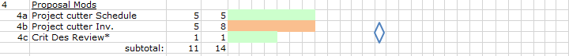 48
Gantt Chart Description 49
Appendix F – Expertise and Resources 50
APPENDIX G – Evaluation sheet (Testing) 50
APPENDIX H – Testing Report 50
APPENDIX I – Testing Data 50
Appendix J – Resume 50

1: INTRODUCTION

1a: Description:
The issue with Boeings new 777X is that the wings are now being produced using a composite. Making airplane wings come with benefits and negatives. The wings are now lighter than before, but cannot be recycled. Once the composite wing is manufactured, the trimmings are kept and disposed without any form of recycling. An estimate given my John Locklear said that about 660,000 lbs of trimmings is deposed of annually. Due to the high amount of scrap trimmings, a method of reusing or recycling of the carbon fibers will be beneficial to the company as well as the environment. The most effective way of salvaging carbon fibers is through a chemical process that CWU do not have the means of doing. So, to bypass that, a machine will be constructed that will cut scraps into smaller pieces that will allow for easier transportation and processing.

The inspiration behind the design given in this proposal is a paper shredder, or a cardboard partition slicer. With rotating shafts connected to a motor, and blades fastened in desired locations, composite material will be able to be fed into the device after delamination and be cut into easier to handle pieces.

1b: Motivation:
This project was motivated by trying to find a method or device that would allow for salvaging some of the carbon fibers from the trimmings of the wings. By finding another use for the trimmings the team would be benefiting both the company and the environment. Also, getting the experience of developing a process to help in recycling of a new, high use material would be beneficial.

1c: Function Statement:
To cut down delaminated carbon fibers into smaller, easier to process pieces.

1d: Requirements:
- Cut composite material
- Reduce a 1750 RPM motor to a minimum a 571 RPM
- Connect cutter to lab partners delaminating process
- Cutting will have to apply a force of at least 546.7 lb-in
- The device must weigh under 80 lb
- Device must cost less than $1500.00
- Use a single, 10 HP motor
- The overall process (delaminating and cutting) will need to be done in one motion

The device will be required to transmit a torque through a gear system that will allow for mounted blades on shafts to be able to rotate while simultaneously cutting scraps of carbon fibers. Depending on the location of the blades, the size of the cut piece will be able to be manipulated by movement of the blades.

1e: Engineering Merit:
The engineering merit to this project is that a device needs to be constructed that will slice composite material. Due to the overall strength of the material, all aspects of the machine will need to be able to withstand multiple trials of cutting material. The manipulating of gears and torque from a single motor will have to produce the calculated RPM that will allow for cutting of material.

1f: Scope of Effort:
This project will only include operations to will make processing and storing material easier. The original success criteria were going to be based off how many individual carbon fibers were salvaged. But since the devices will not be chemically processing, they will focus on delaminating and cutting instead.

Also, after speaking with John Locklear, an analysis of how this project could be scaled to a full facility was mentioned. Since the scale of this project is small, a potential idea of how to pre- process this material will be developed and a prediction of how this could be scaled up will be calculated. The results generated will be able to be scaled up for a full operation.

1g: Success Criteria:
Success for this project will be based on having a functioning cutting machine by the end on winter quarter or early spring. By functioning it will be able to cut through material that has been delaminated in an earlier process the entirely of the original length.

2. DESIGN & ANALYSIS

Proposed Solution

The idea behind the cutting device was inspired by a cardboard partition slitter, or a paper shredder. After a conference call with John from Boeing, it was made evident that an excess of 660,000 lbs of trimmings are accumulated over a year. The cutter was believed to be an efficient way of processing mass amounts of bulk if developed to a full-scale piece of machinery. The idea of feeding a single piece of material into a opening and having sliced pieces on the other end machine would call for easier transporting as well as processing.

Through a motor generating the power, a series of shafts as well as gears will transmit calculated torques that were calculated after an experiment.

Analysis
An experiment was conducted using a hammer, a cut piece of composite and a chisel. By measuring the height at which the hammer was raised, the weight of the hammer and kinetic energy, a starting energy was calculated and scaled for a full-size piece of composite.

Energy Experiment

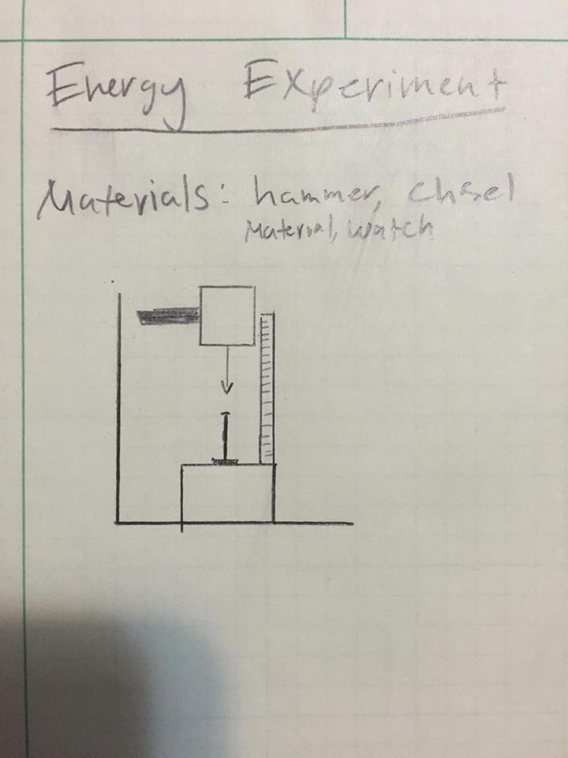

The image provided was a sketch of how the experiment was conducted. As shown in the image, a hammer was dropped from a certain height which was recorded. A stop watch was timing from initial movement until contact with the chisel. A success to the experiment was based on if the chisel went through the material. The calculation for this experiment can be found in appendix A.1d. By measuring the height at which the hammer was raised, the weight of the hammer and kinetic energy, a starting energy was calculated and scaled for a full-size piece of composite.

Analysis from Experiment

After calculating an initial energy, another calculation was done to scale the experiment to a full-size piece of material using conservation of energy. This calculation is in appendix A5.

After the scaling of the energy, a required RPM was needed to be calculated. Going back to KE=1/2mv², the mass was the variable that was altered so that a tangential velocity could be calculated. After the tangential velocity was calculated, a RPM was then calculated. Once having the necessary RPM, minimum diameters were calculated based off the calculated RPM and the RPM provided by the motor that was selected from Mccmaster Carr. The main requirement of this device will be to cut material after is has been delaminated into strips.

The original RPM calculation can be found in appendix A7. The following shaft diameters can also be found in appendix A9.

At CWU, a form of analysis is used called RADD. A requirement, analysis, design and documentation are needed in order to complete a RADD. Since the overall goal of the machine is to cut material, the experiment done was to find the necessary energy needed. From there, shaft diameters and blades were found as design parameters.

The image provided is the general layout of how the machine will be powered. It is shown that the motor is connected to a shaft that will transmit a torque through the mating gears. With blades mounted on the shaft at desired distances, material will be able to be fed through an opening in the housing which will cut delaminated pieces into thinner, easier to transport and process pieces.

Performance Prediction and Scope

When predicting the success of the device, considering that all components are fastened securely, and the desired torque is met, the cutters should be able to cut through material. A potential issue that could arise the integrity of the cutters. When cutting material for trials in the foundry at CWU, the tungsten carbide blade was sufficient to cut through. But when speaking with John, he said that they use steel cutters and go through a lot of them. The biggest risk then would be finding cutters that would be able to cut through multiple rounds.

Another aspect that will determine success the level of delamination that will occur and the consistency of the delamination. If the fed material is delaminated across all levels, resin will be compromised and should allow for smoother cutting.

Engineering merit of this project will be based on the construction and success of the device. The manipulation of torque based off of a given motor involves calculations and using energy and an experiment to find a RPM that needs to be achieved.

The scope of the testing will be smaller compared to the proposed full warehouse John had us think about. The proof of concept if successful will show that a delaminating and cutting process done in one motion would be able to work.

3. METHODS & CONSTRUCTION

The project conceived this project after taking Plastics and Composites. A Boeing engineer, John Locklear presented us a problem with the recycling of composite material. Using the resources provided by CWU and the MET program, as well as a funding from JCATI the group will develop a bending and cutting process that will be attached together into a single machine. The goal of the combined machine will be when a single piece of material is fed into the bending process, it will move through into the cutting process and come out in strips at the end.

Using Kinetic Energy (1/2mv²), an initial energy was calculated through experimentation. The energy calculation guided the design. Minimum diameters was based off of the energy, blades were selected based of mass, and gears were selected that would apply the needed RPM.

Refer to renderings
In Appendix B, drawing 3 and 4 show diameter calculations. A minimum was calculated but sized up so that fitting with other components would work. The corresponding calculations can be seen in Appendix A 6 and 8.

Device Operation
The device will operate when the AC motor is powered. A delaminated piece of composite material will be fed through a hole in a plate into the rotating cutters. The piece will be fed until it is completely cut the entirety of the given length. Blades should be adjustable to dictate width of cuts.

Benchmark Comparison:
Due to the inspiration behind the design is based of a device like a paper shredder, it is hard to compare. After preliminary testing, it was found that 9000 lbs was the minimum force needed to break the integrity of the resin. So, the proposed device could be compared to a paper shredder but with a x100 power need. There are also cardboard slitters. But all comparisons need to be magnified significantly because unlike paper, this machine purpose will be to cut composite material.

Another piece of equipment that the cutter could be compared to is a wood chipper. A Kowloon diesel wood chipper has a motor that ranges from 60-100 HP. The proposed solution uses a 10HP motor. So the cutter being designed would have 12.5% of the total power of a commercial wood chipper.

Performance Predictions:
If all components are assembled and secure, the device will be able to cut material using only 36% of the total RPM output of the proposed motor.

4. TESTING METHOD

Due to the motor having a variable RPM, a test will have to run in order to find what RPM will provide the best for cutting the composite material into strips. The device will have rotating shafts with cutters mounted onto them. The engine will be fixed and connected to a gear train which will transmit power to the device. Due to the material being as hard as it is, experimenting with the power of the motor will need to be done to better predict the RPM vs thickness of the material. Using the calculated minimum RPM that will be the benchmark in which testing will be done.

Test Plan:
The information and equipment that will be needed is a sensor to record the RPM of the shafts. A similar method was used in a thermodynamics lab and that model of testing for RPM will also be used for this device.

The second part of the test will be focused on how efficiently the blades will cut the composite material. The ideal test would include a variable RPM depending on the thickness of the composites that will be cut by the device. A spreadsheet maybe be utilized with variables thicknesses and RPM to predict whether the device will perform by cutting apart the composite material.

Test Documentation and Deliverables

Test data will be collected on an excel spreadsheet so that analysis can be done on variable thicknesses and RPMs. By experimenting the RPM and thickness of material, scaling of a larger, more powerful machine will be done.

BUDGET/SCHEDULE/PROJECT MANAGEMENT

Budget

The budget for this project is $5000.00 due to a grant that was secured from JCATI. A considerable amount of that budget will be spent on the delamination process due to the power that is needed to delaminate. The current proposed device has an estimated cost of $1567.86. That total is subject to change with the possibility of getting material and labor donated. There is also a risk of raising the price if more intricate parts will need to be machined to tight tolerances.

Prices were determined from McMaster-Carr for appropriate parts. Raw material was estimated.

A parts list with costs is provided in Appendix C.

Schedule

An estimated schedule is provided in Appendix E in the form of a Gantt Chart as well as an description. The overall schedule is dictated by CWU MET 489 A-C. A proposal is due at the end of fall quarter. The working device will be done sometime within winter and spring quarter. The final project will be due at the end of spring quarter.

The winter break will provide time to work on drawings and completing a more detailed assembly.

Project Management

This project is managed by the designer and the other member of the team. Advice and expertise is given in the form of emails from John, as well verbally in meetings with professors. The Senior Project series come with a schedule and deadlines. Those dates dictate the pace that certain aspects get done. The winter will be focused on the building of the device while spring will be on testing and presenting the results.

Risk Analysis

One potential risk that the team might face is over spending. Since both operations need separate motors, and high power motor for delamination, a potential to use all funds is likely. Another risk that must be accounted for is if the blades do not last for multiple cycles. When speaking with John, the use of steel cutters was mentioned and that a lot of them were used and tossed because of the composite material.

DISCUSSION

The development of the design has changed a few times over the quarter. At first a device was conceived that would allow for delamination of the material using equipment provided by CWU. But considering that there are two people working on this project, the scope needed to be expanded. That was when the group broke off and focused on delamination and cutting. Once the concrete purpose of the project was addressed, then research and ideas of how to cut the material was developed. The shredder is an efficient way that would only need a single person to operate.

Upon completion of the experiment, a more focused path was set in completing from analysis that would allow for design parameters. The experiment was instrumental in getting some initial values to base the design around. By doing the experiment and using kinetic energy, the changing variable that can be used is the mass of the blade. Finding heavier blades out of a material that can cut through composite still needs to be determined prior to any funds being used on them. But knowing the RPM requirement, the machine should work once constructed.

The ongoing changes have been frequent. The recent development that has the two devices being joined into has called for a few problems that will be addressed during the coming break. A delamination process and cutting process now needs to happen in series, with one initial movement. Focusing on the housing, gear box, motor connections and fastening the entire machine has proven to be a challenge but significant progress has been made. At the current rate once material is ordered and machined, the only potential problem could be the cutters and seeing if they will be able to survive multiple rounds of cutting. And finding a way to secure the entire machine that does not involve a large, heavy piece of steel needs to be analyzed due to the potential rise in cost.

CONCLUSION

Upon completion of the device, a successful project would produce cut material at desired widths due to the blades being adjustable. The project would have met the requirements of getting all power from a single motor, costing under $1,500 and successfully cutting composite material. The major requirement that was recently brought to attention is that both the delamination and cutting must be put together into one device with two separate components. A successful project will count on having a single device, performing delamination and cutting in two separate processes, but with one initial movement. Material should come out in the end delaminated and cut to desired width that will allow for better processing (1in). The expected results based off the calculations is that material should be able to be cut if blades are at least 1 lb each, and rotate at 571 RPM.

.

ACKNOWLEDGEMENTS

A special acknowledgment to Dr. Johnson for guiding the ideas behind this project. And Dr. Johnson went out of his way and was able to secure a grant that will be used to finance the project. JCATI for supplying the group with funds and an opportunity to share the ideas and results of the project.
Also, a major thank you to professor Pringle for helping with the idea and fine tuning the details. It was through the spreadsheets provided by Professor Pringle and his genuine interest in the project that problems were able to be faced and dealt with.
And for John Locklear from Boeing for giving the team the opportunity to work on this project. John supplied the group with valuable information that will be used in the process of developing and building the machine and scaling of the potential operation. It was through a colleague of John that a recommendation was given on the type of blades to use.
Also, to Matt Burvee and Ted Bramble. Matt was able to provide valuable insight on machining and provide lab hours. Matt also was the person in charge of ordering materials and parts and always did them right of way. His advice on machining and helping with complicated machining tasks helped to provide a working device. Ted was able to help achieve the center to center distance that made it possible for the gears to be able to rotate and have contact.

APPENDIX A – Analyses

A.1 Gear Properties
Gear properties that will suit my RPM requirement. Spread sheets have been made due to the number of time this project has been changed to quicker do calculations.

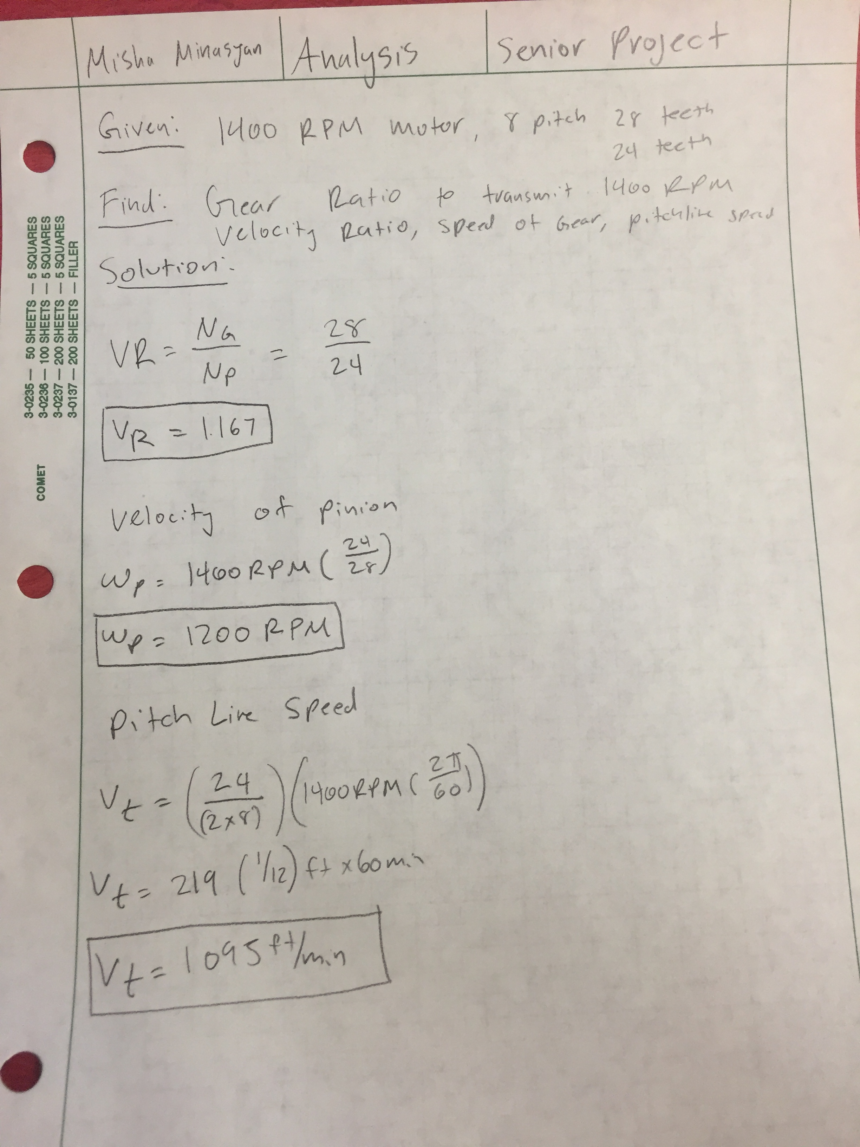

A.2 Housing Requirements:
Housing requirements to house gear system. Spreadsheet has been made to quicker make changes due to the ongoing changes that have happened.

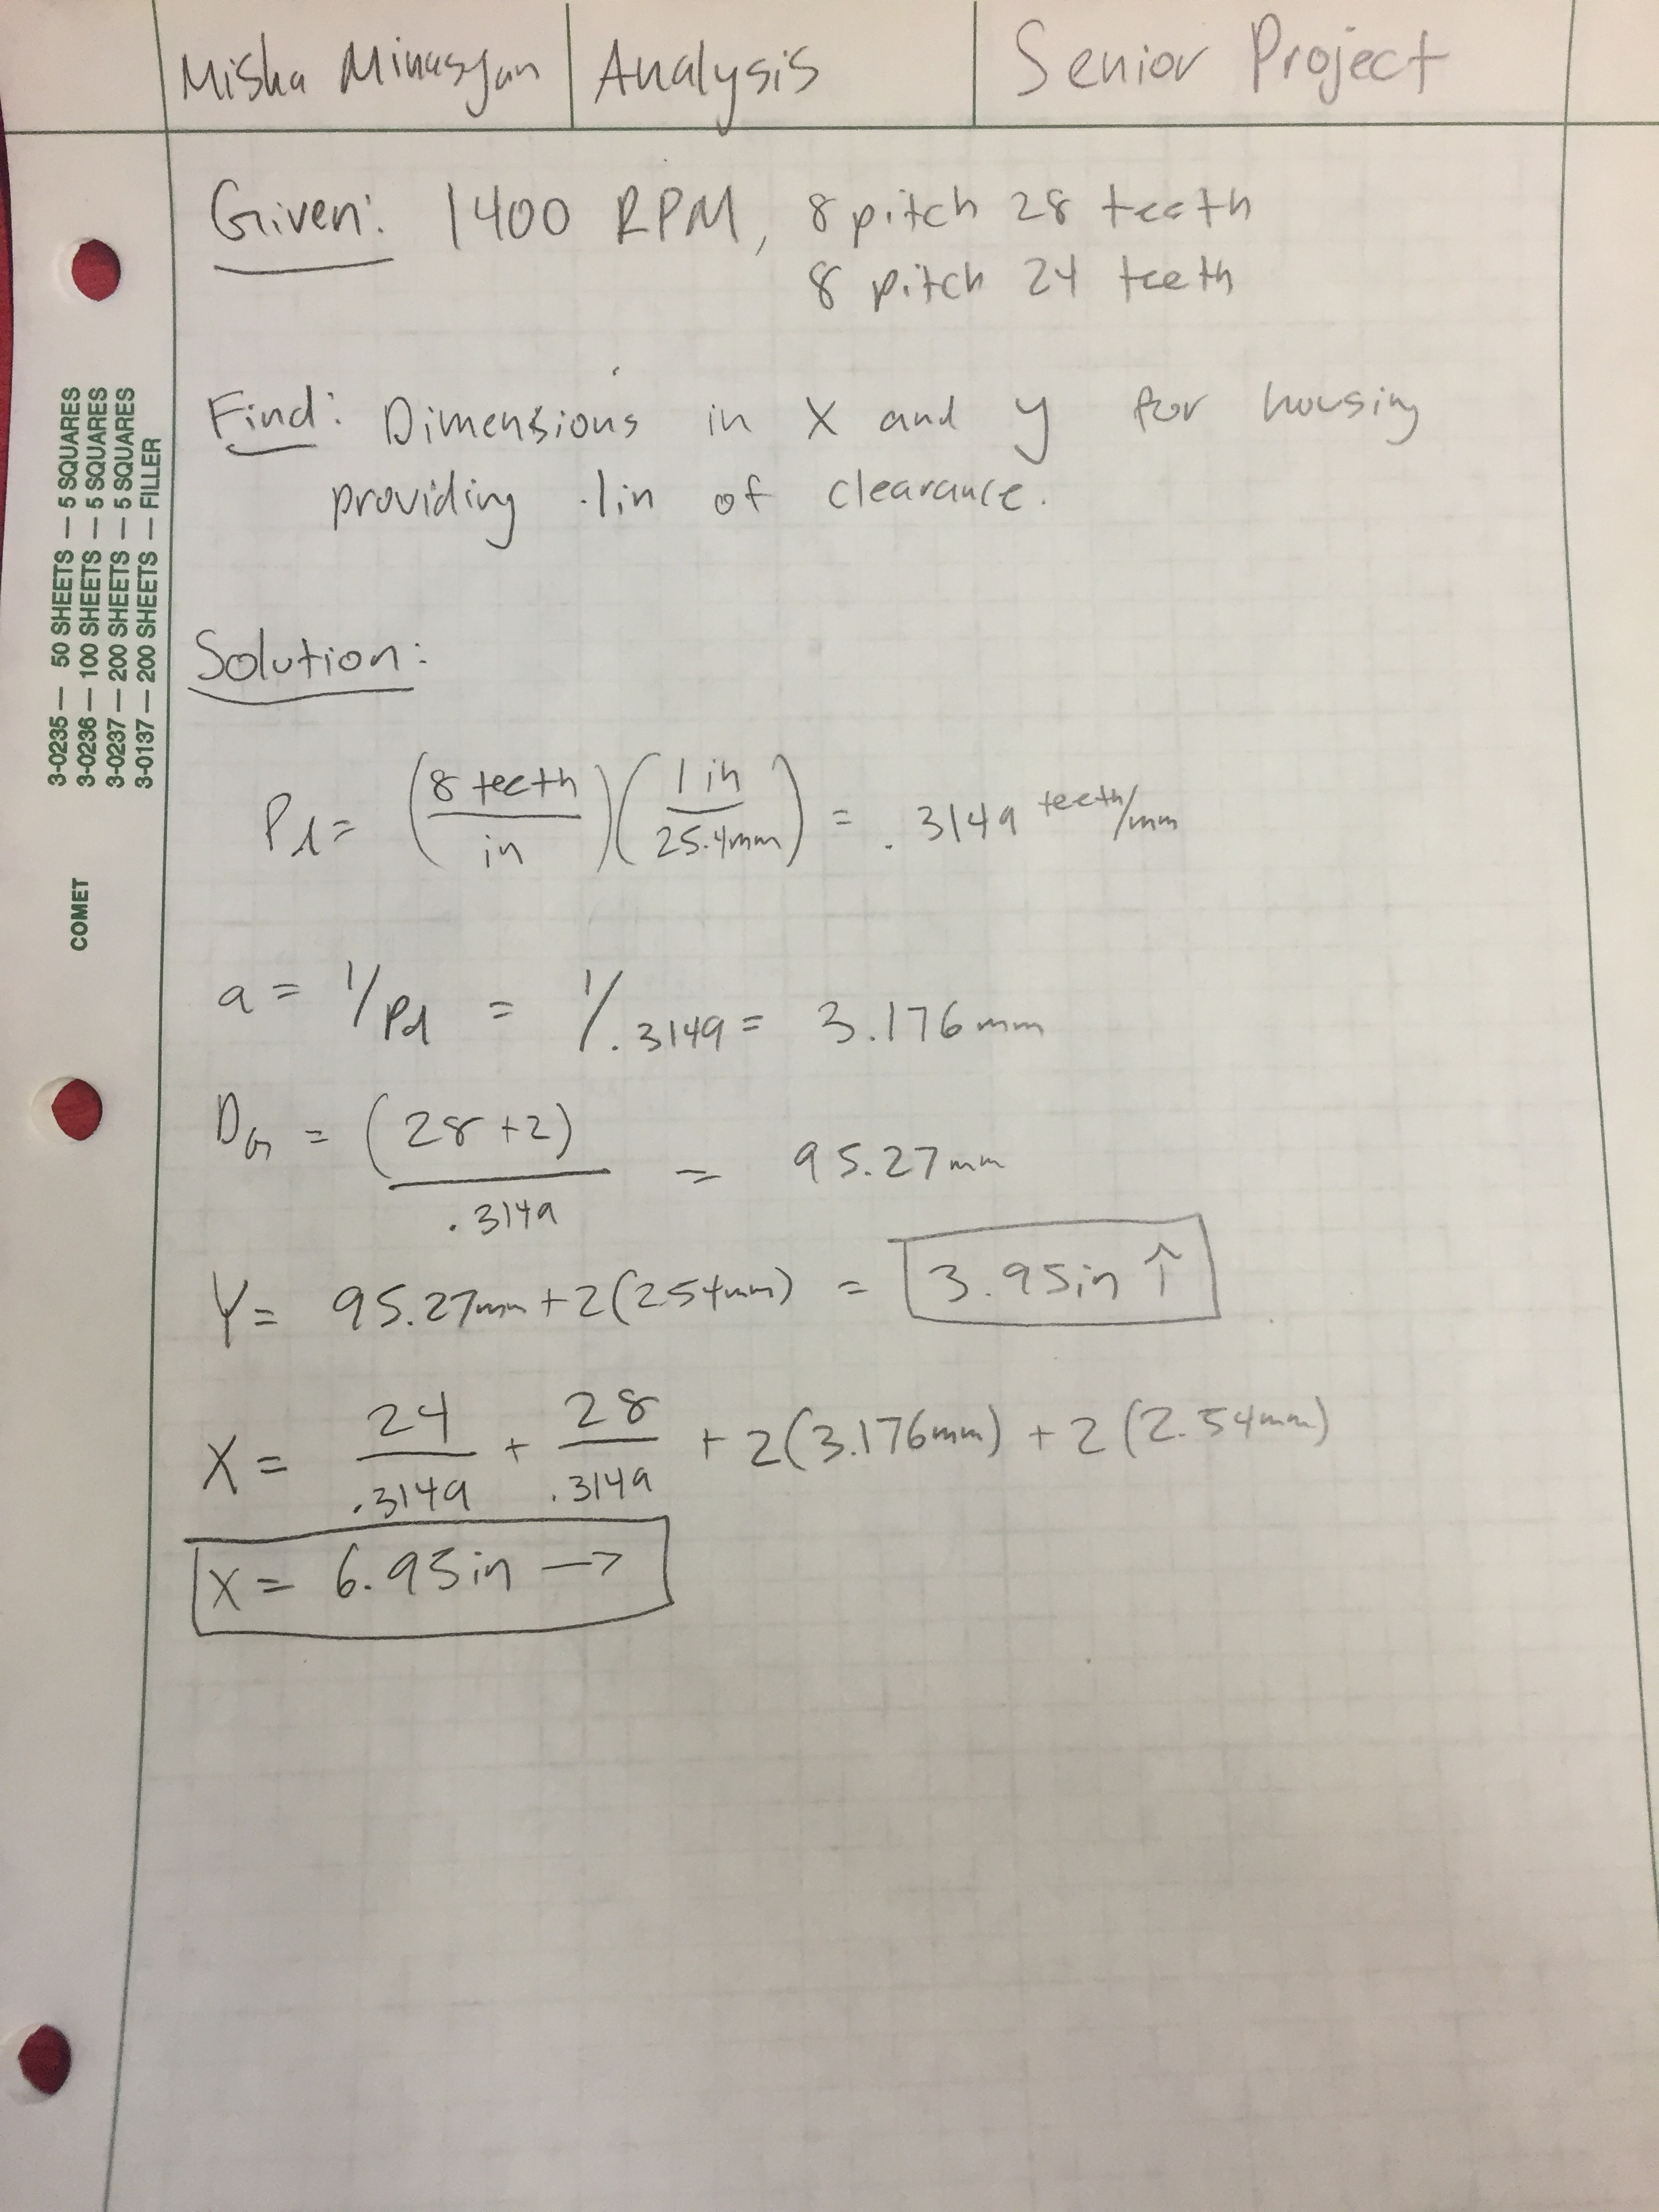

A.3 Bending Stress Calculation:
Bending stress calculation. Spreadsheet has been made to quicker make these calculations.

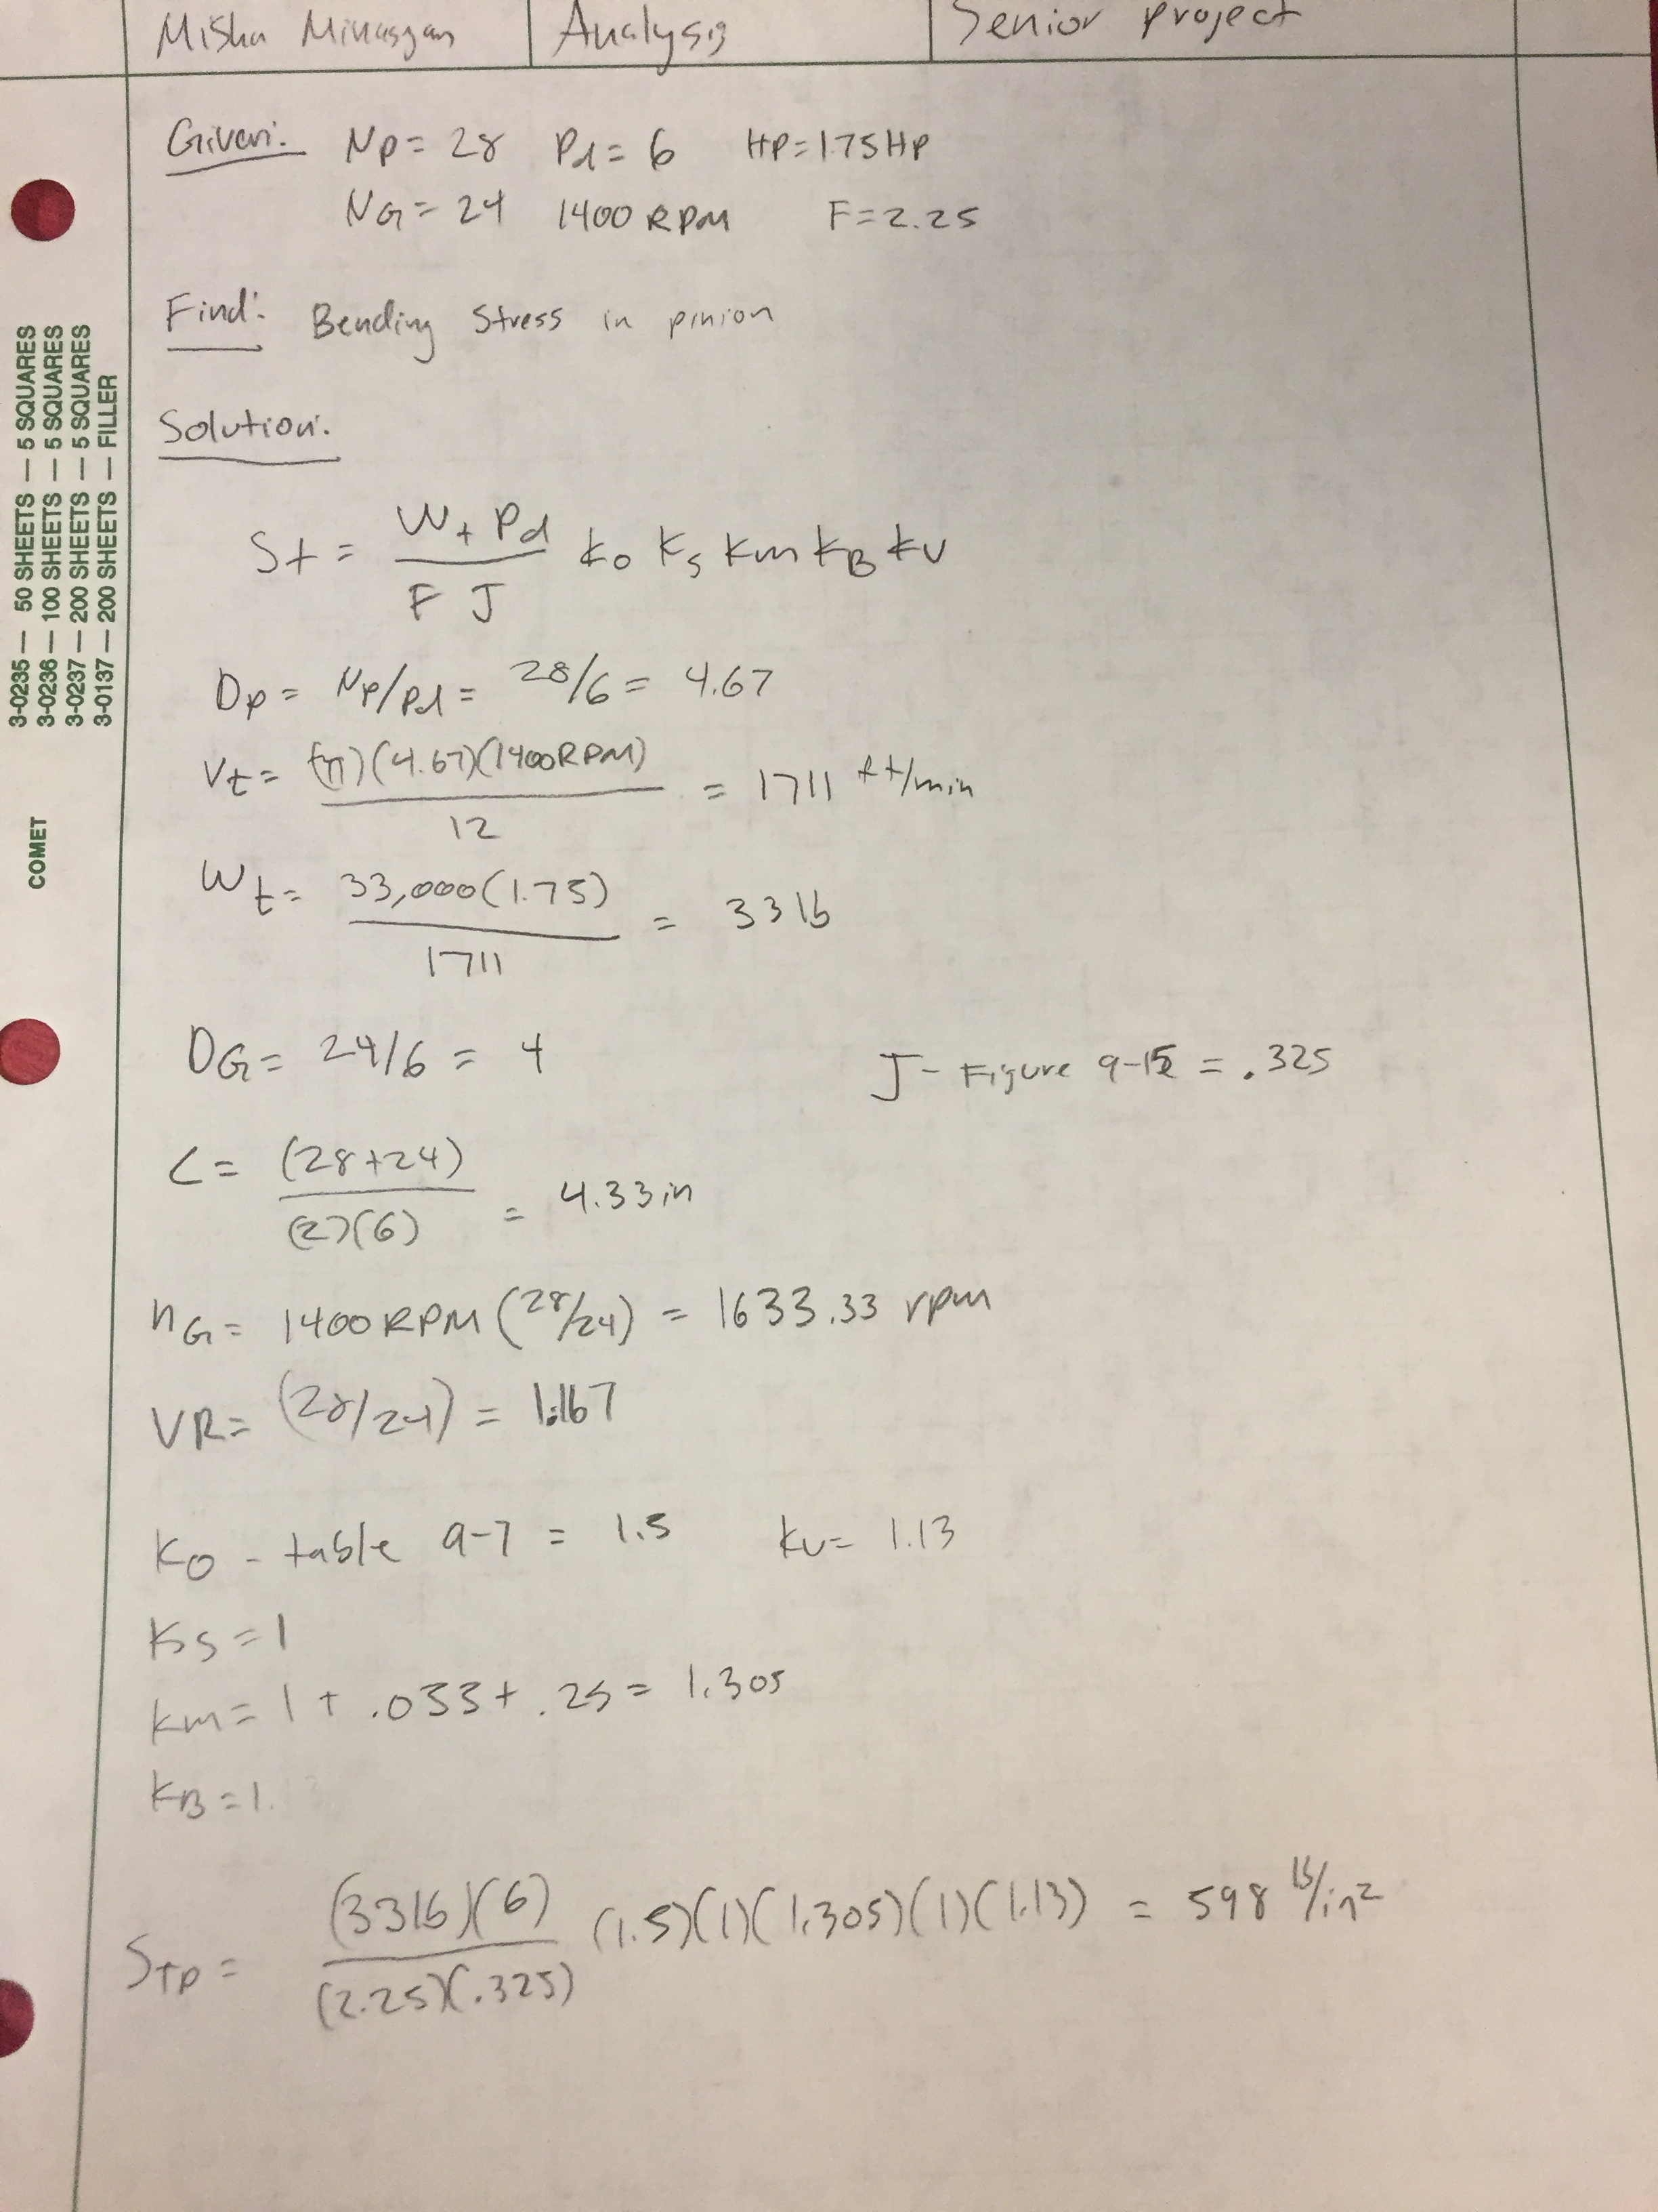

A.4 Kinetic Energy Calculation:
An experiment was conducted to find the kinetic energy. Using a hammer and chisel, a kinetic energy to fracture a 5/8” strip of composite material was done.
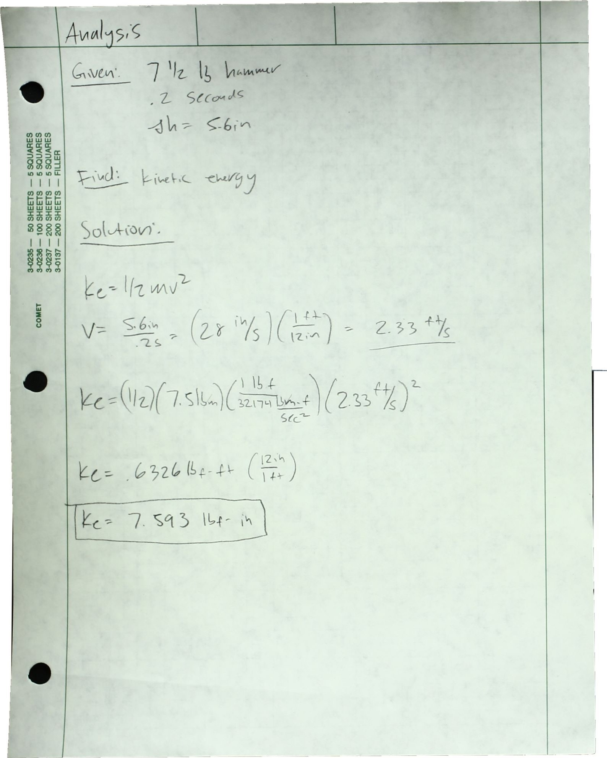

A.5 Scaling the Kinetic Energy
Using the conservation of energy, and the area of the test specimen, a new energy was calculated by using the proportions and calculated energy.

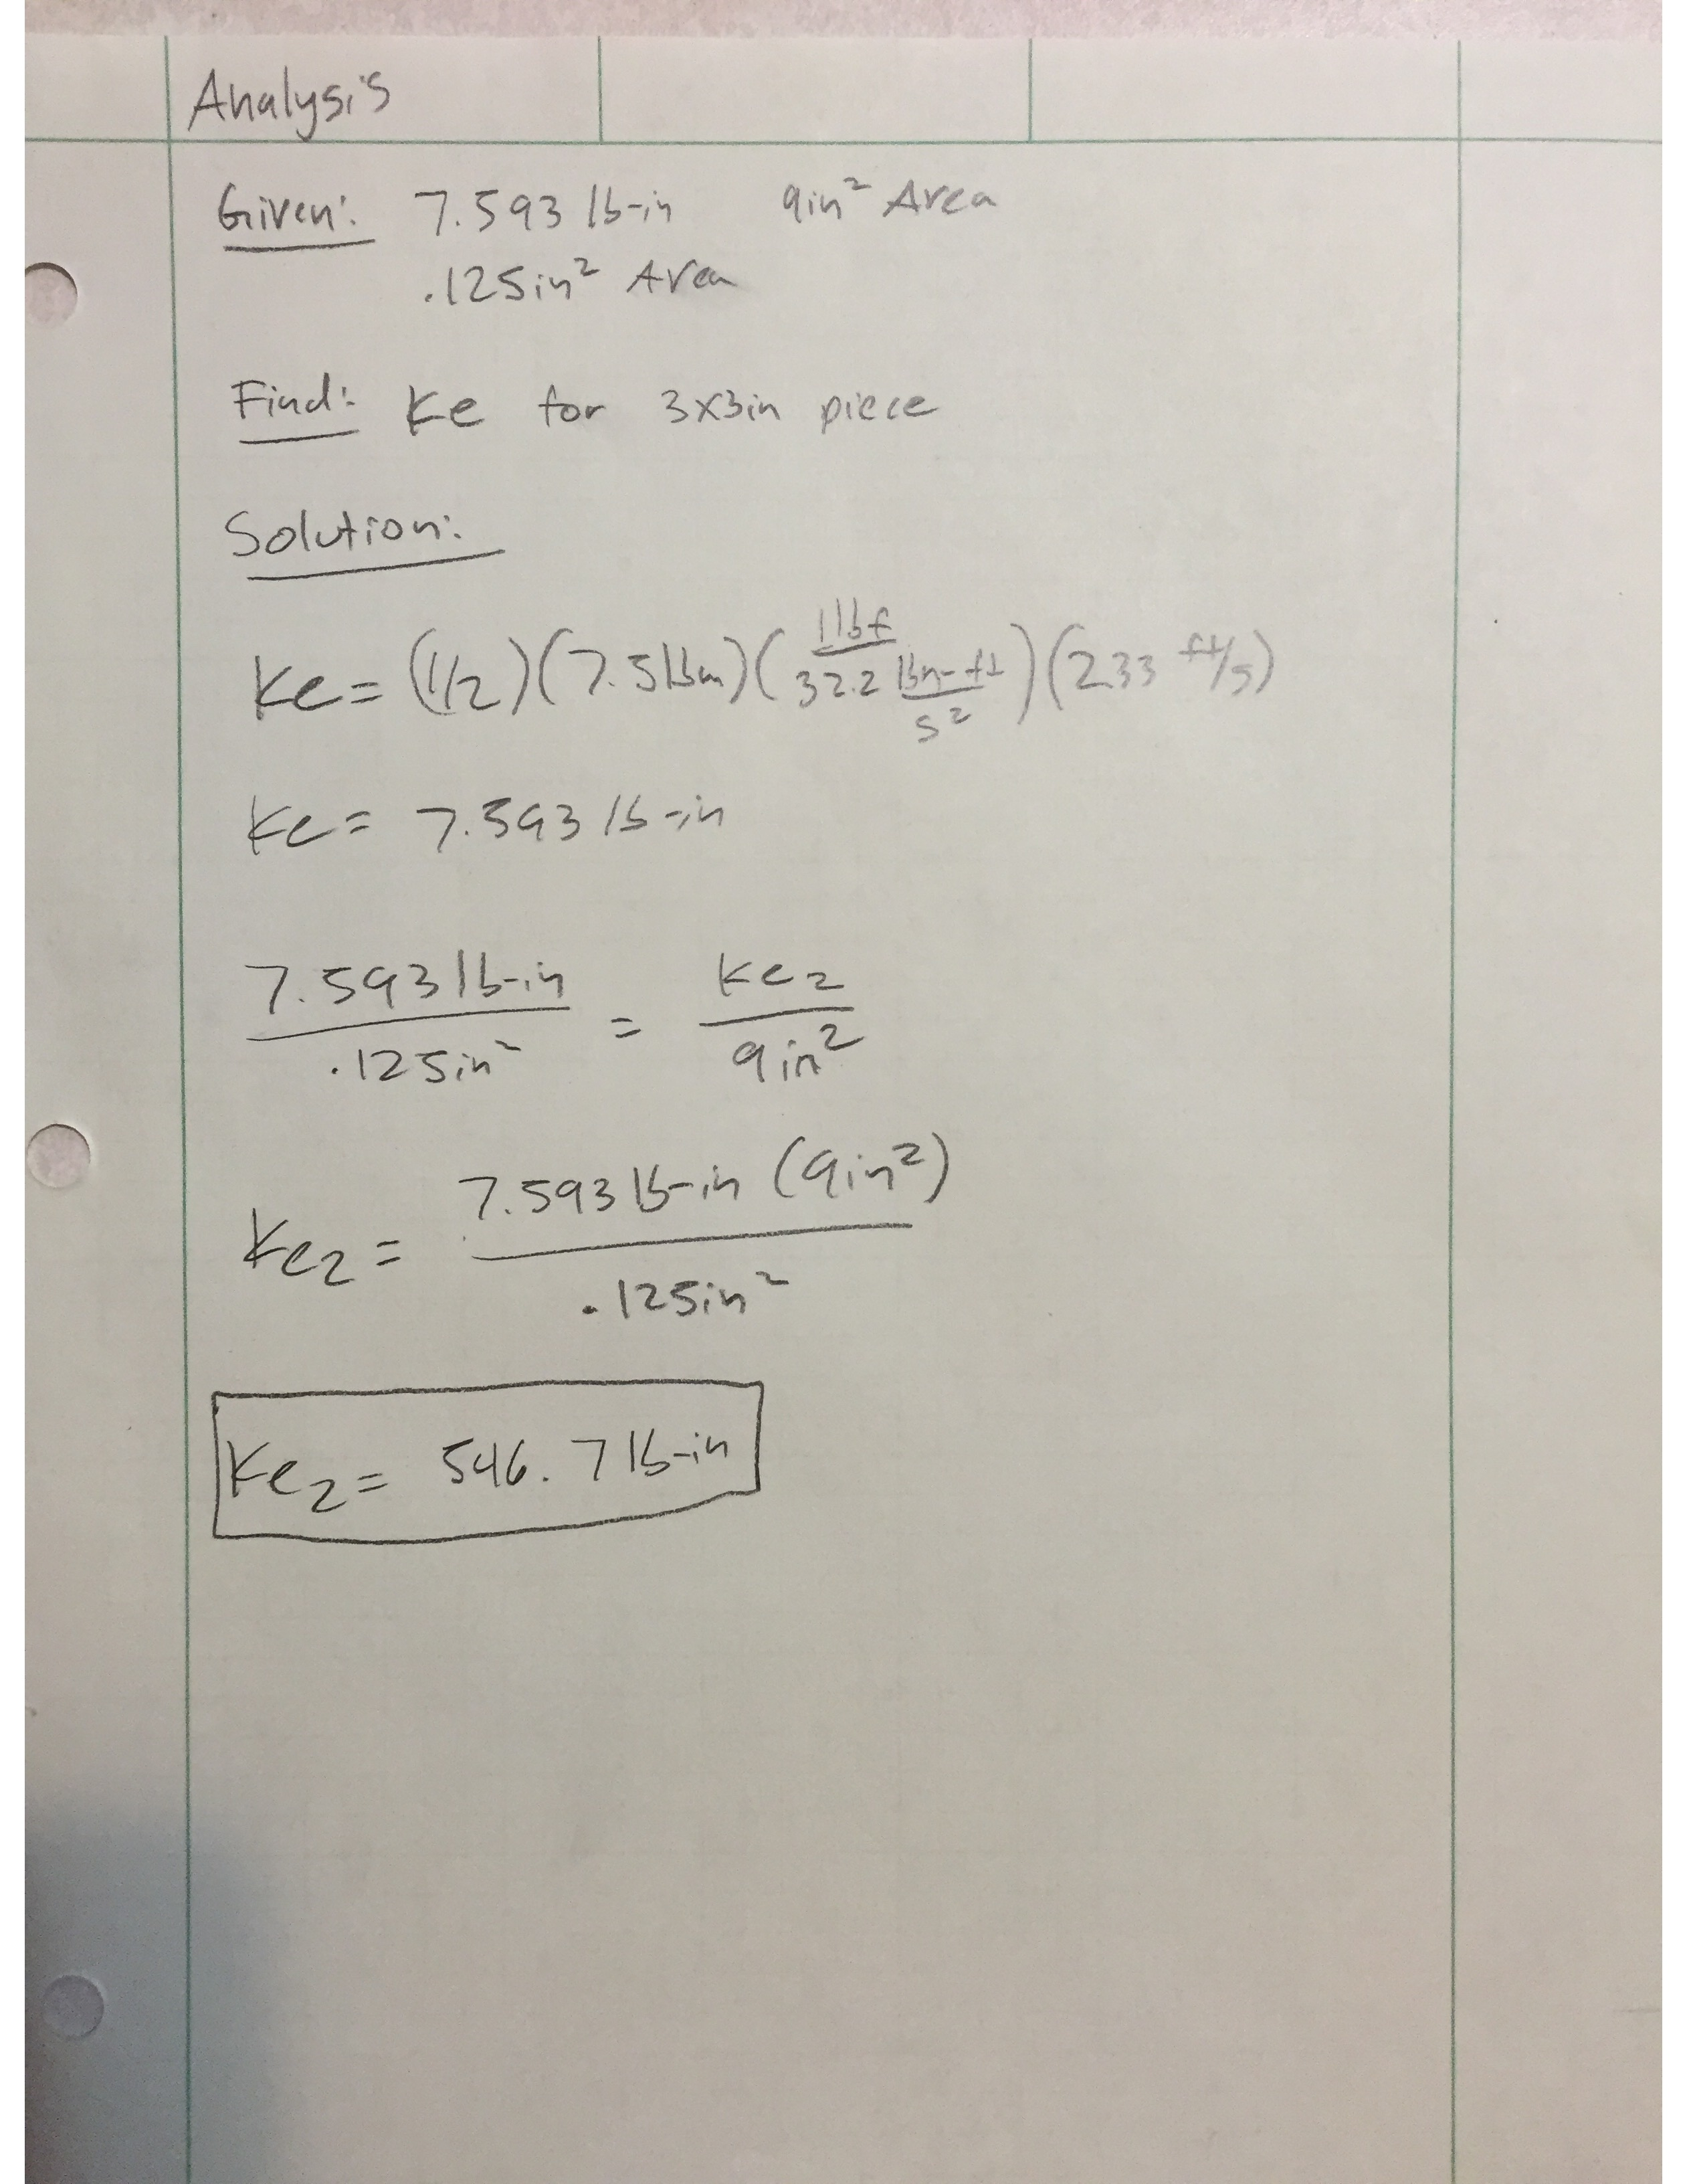

A.6 Minimum Diameter

Depending on the required RPM and power, a minimum diameter can be calculated. Using the text book for MET 418, a minimum diameter was calculated, and the shaft was designed with the diameter. The diameter needed to be larger so that it could fit with the other components but the minimum was met.

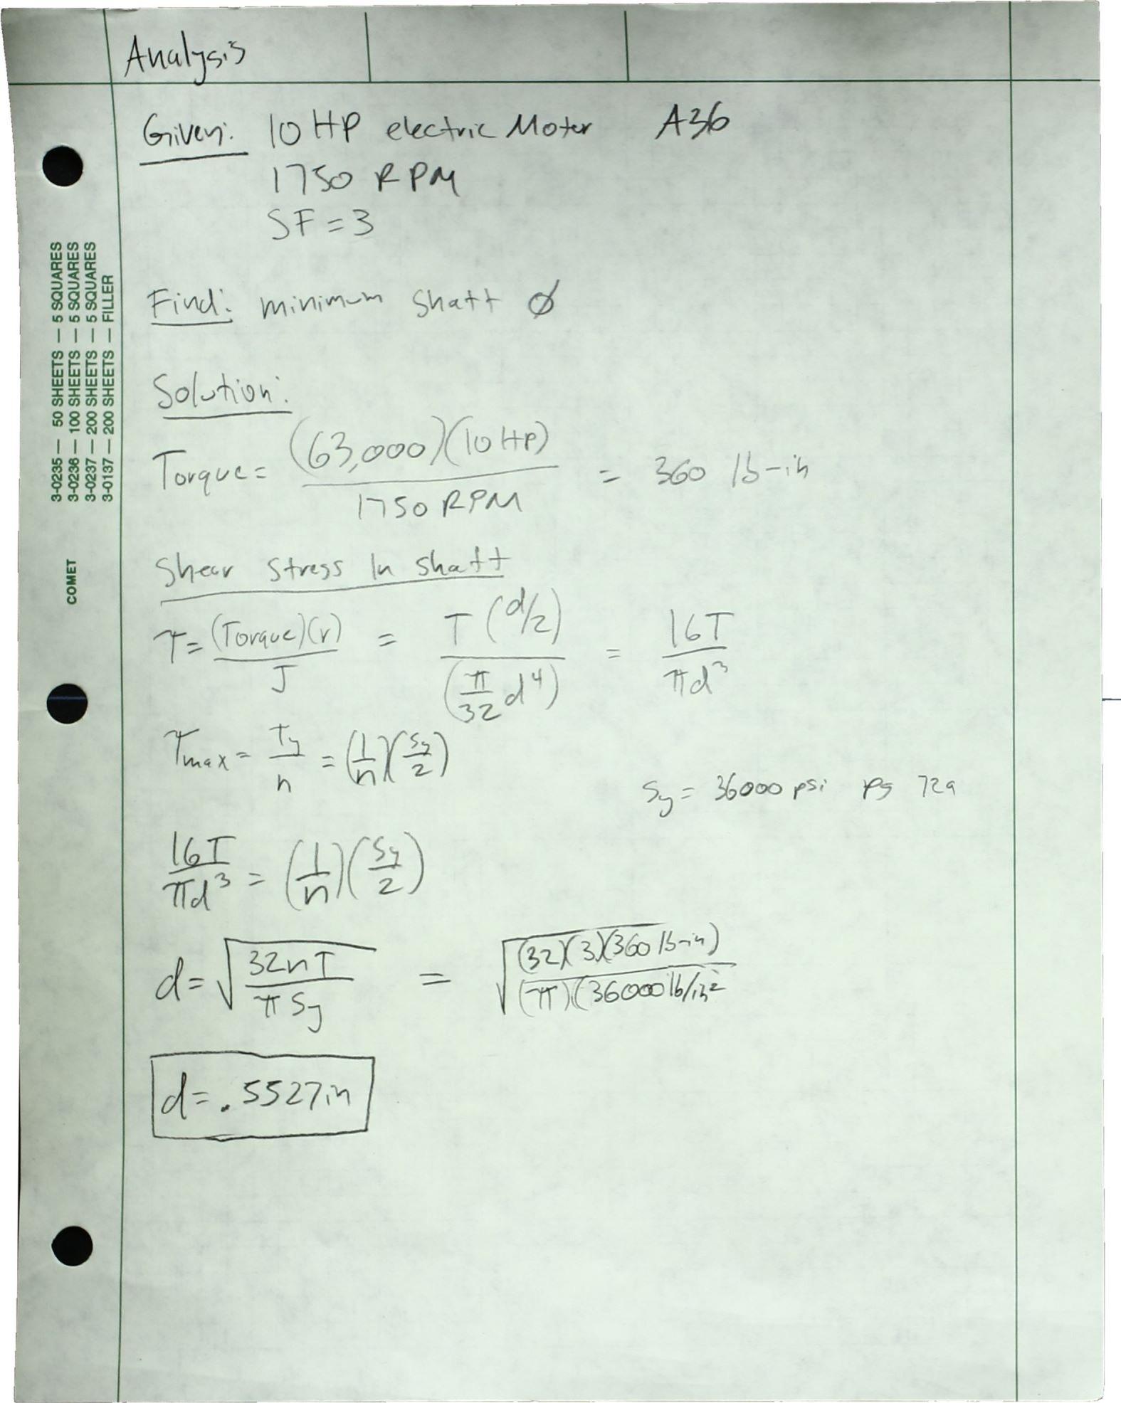

A.7 RPM Requirement

Working backwards after an energy was calculated, a tangential velocity was then needed for a piece of composite that has the original thickness. From there, a tangential velocity was calculated and converted in a RPM which will be used as a started point when testing the completed machine.

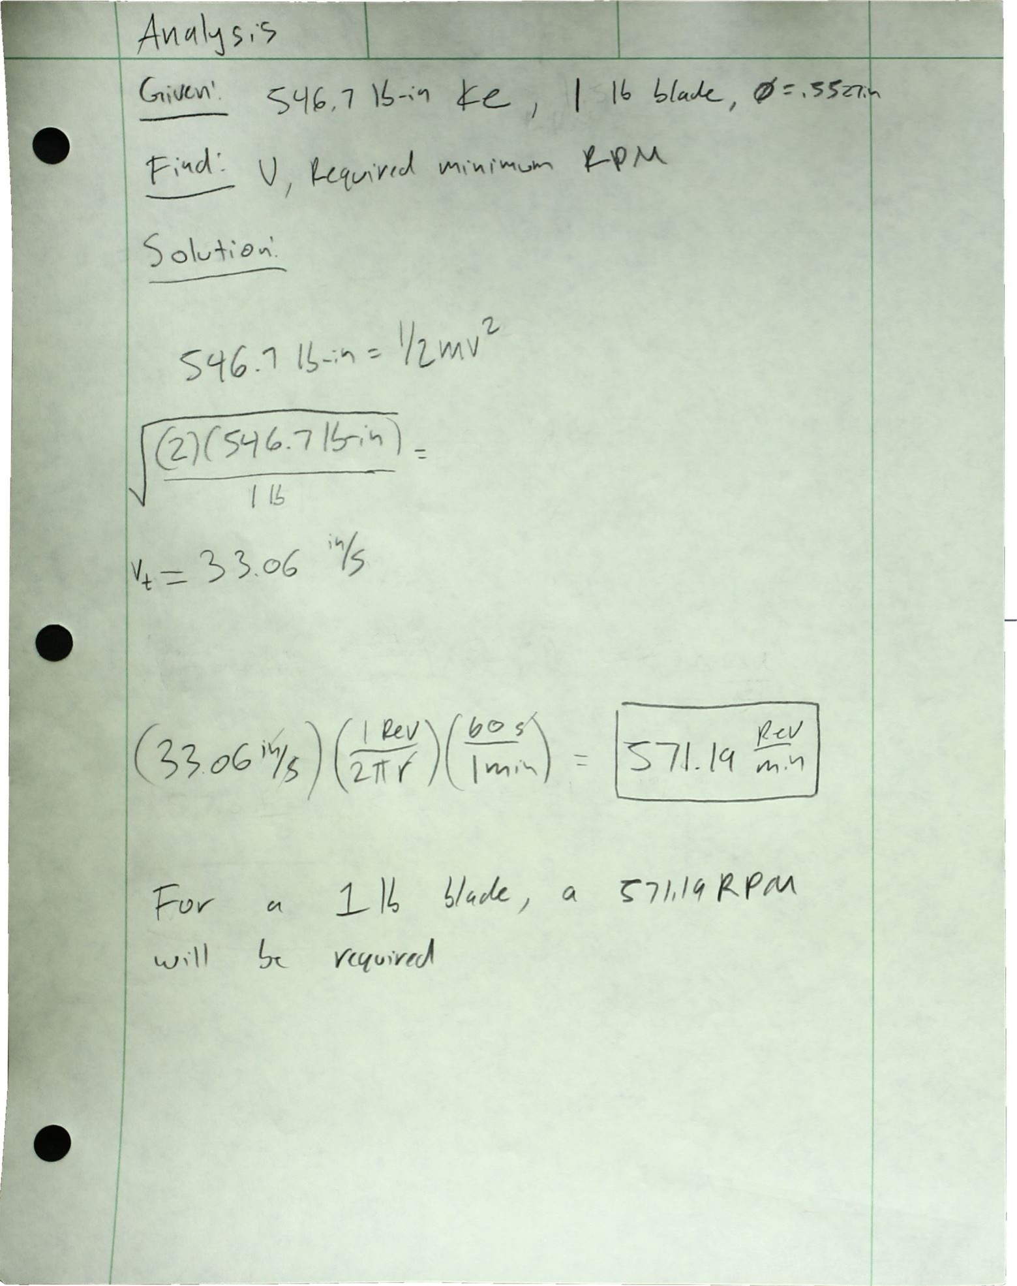

A.8 Second Minimum Diameter Calculation

Since there an initial RPM and a second RPM transmitted by the gears, a second minimum diameter was needed. Here minimum diameter that the shafts that will have blades attached to them will need to work with the RPM that will be transmitted. The diameter was changed, but was larger then the minimum calculated here.

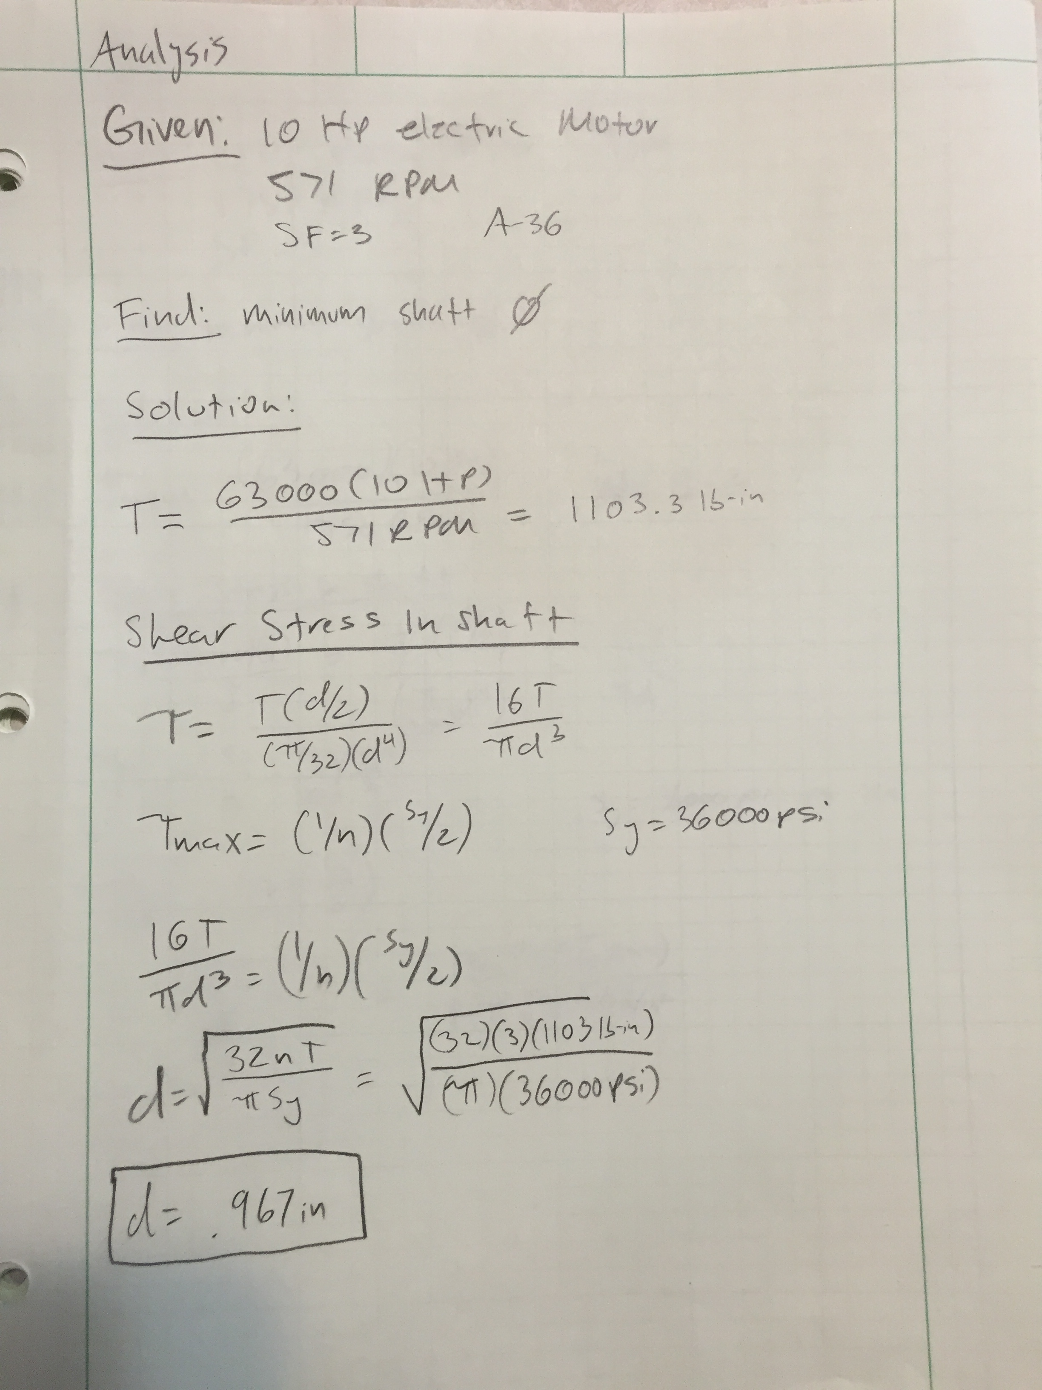

A.9 Key Calculation for Cutting

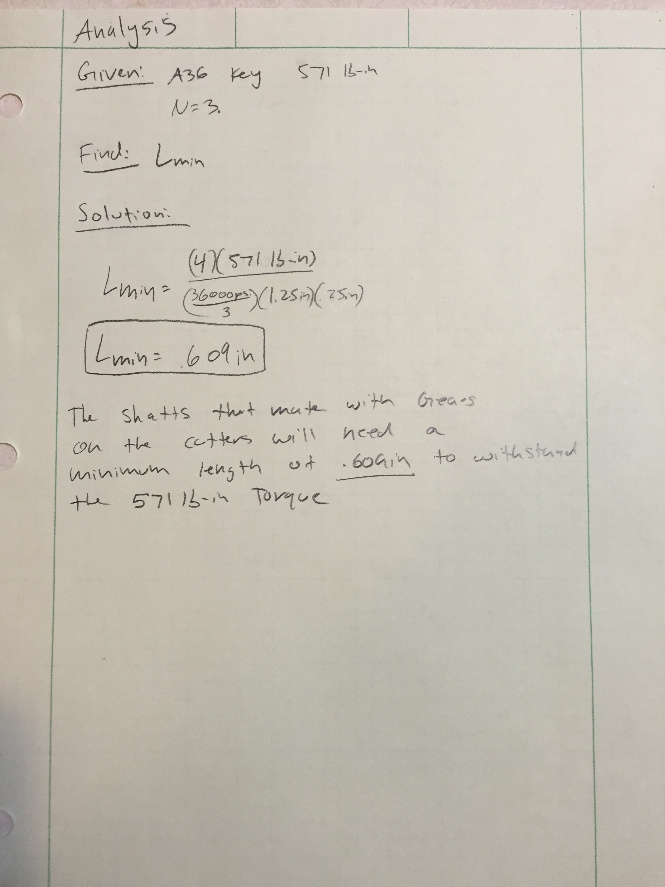

A.10 Key Calculation for Motor

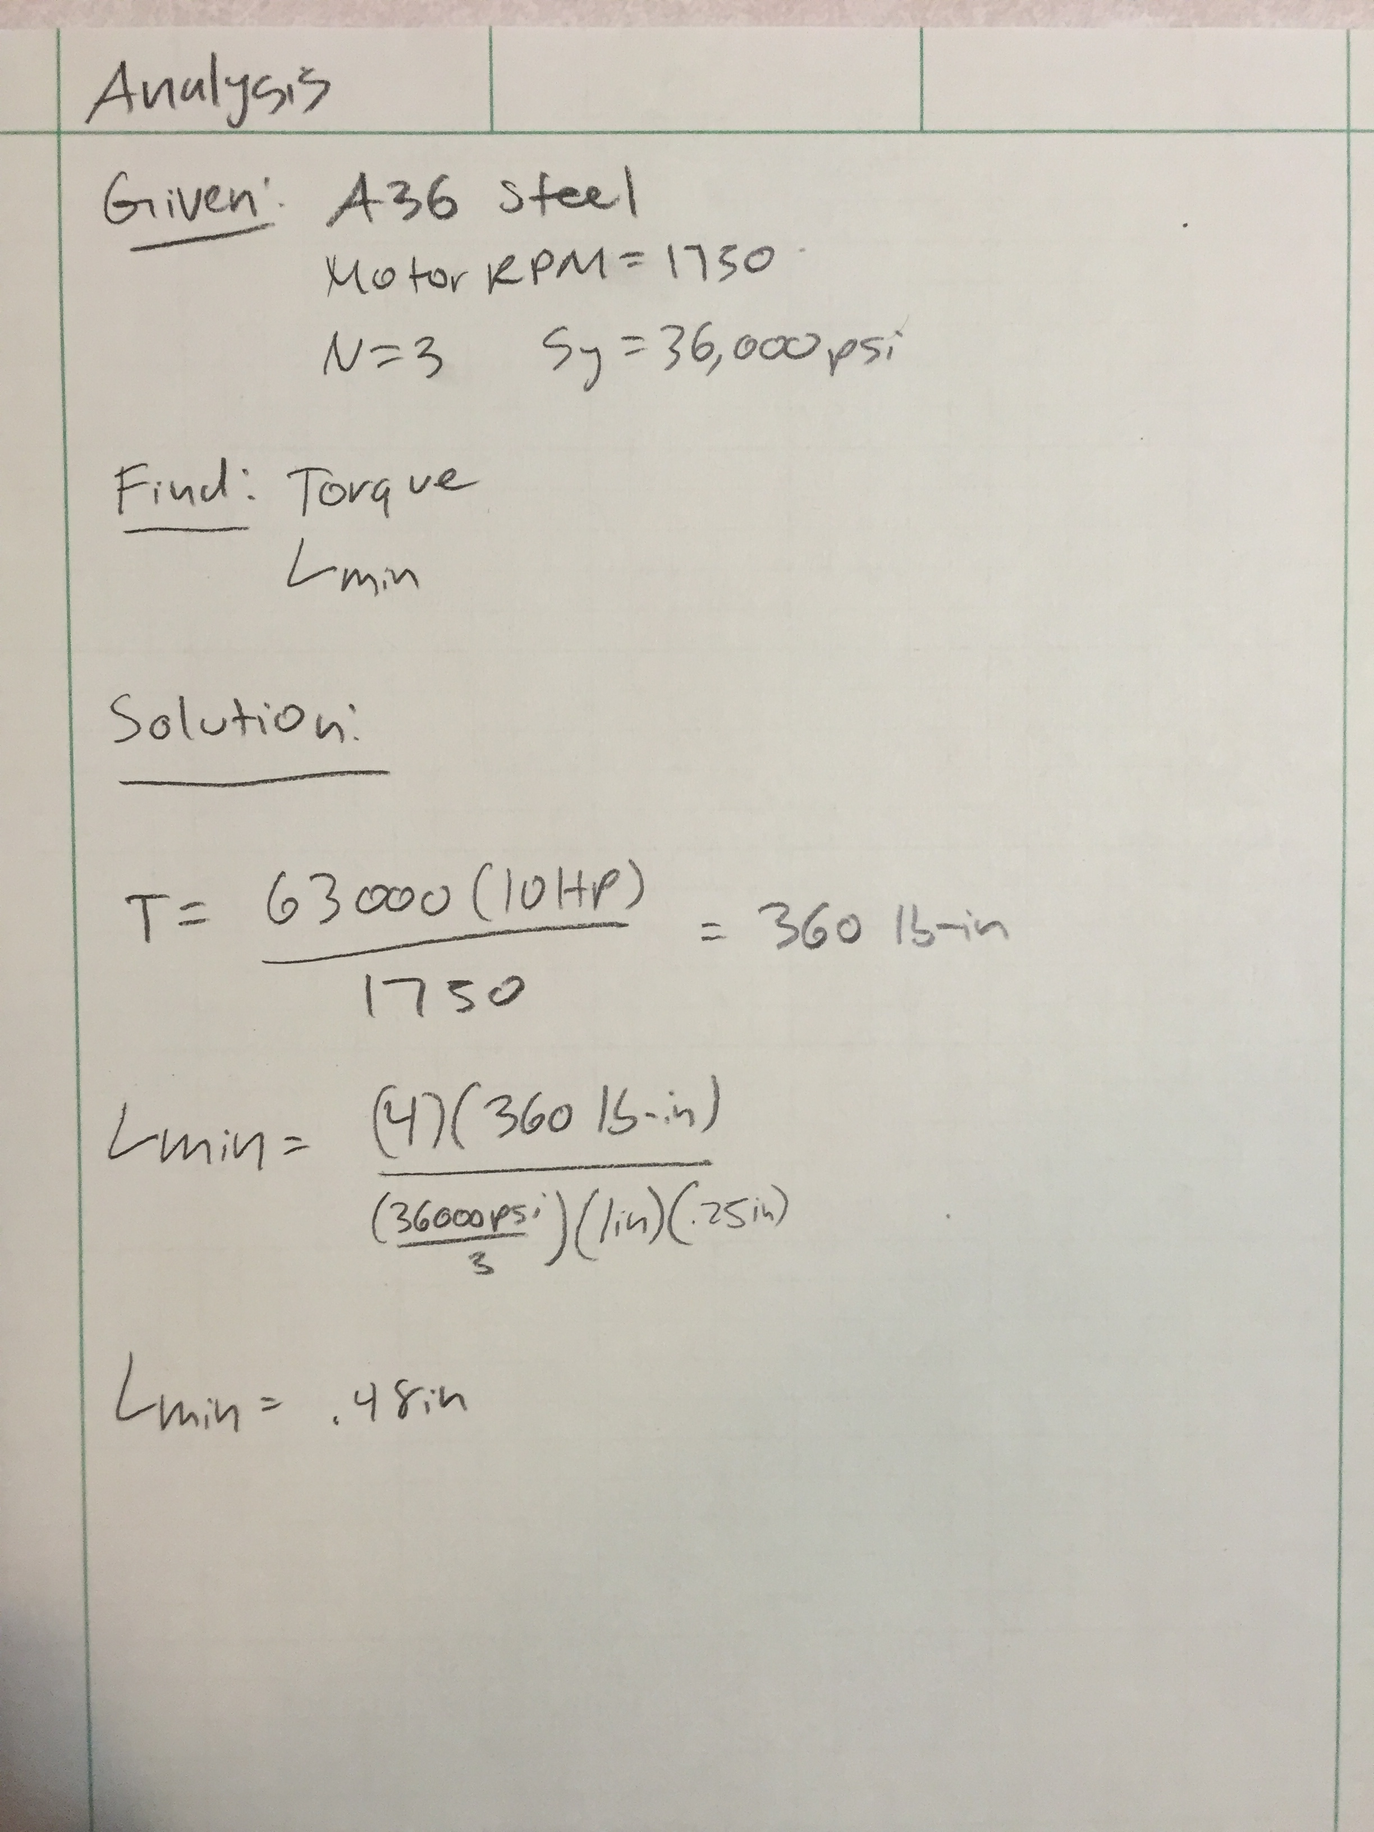

The minimum length of the key that will connect the motor to the gear needs to be .48 in. The designed key is equal to the length of the coupling found on Mcmaster-Carr. See drawing B5.

A.11 Diameter for Pins Connecting Housing

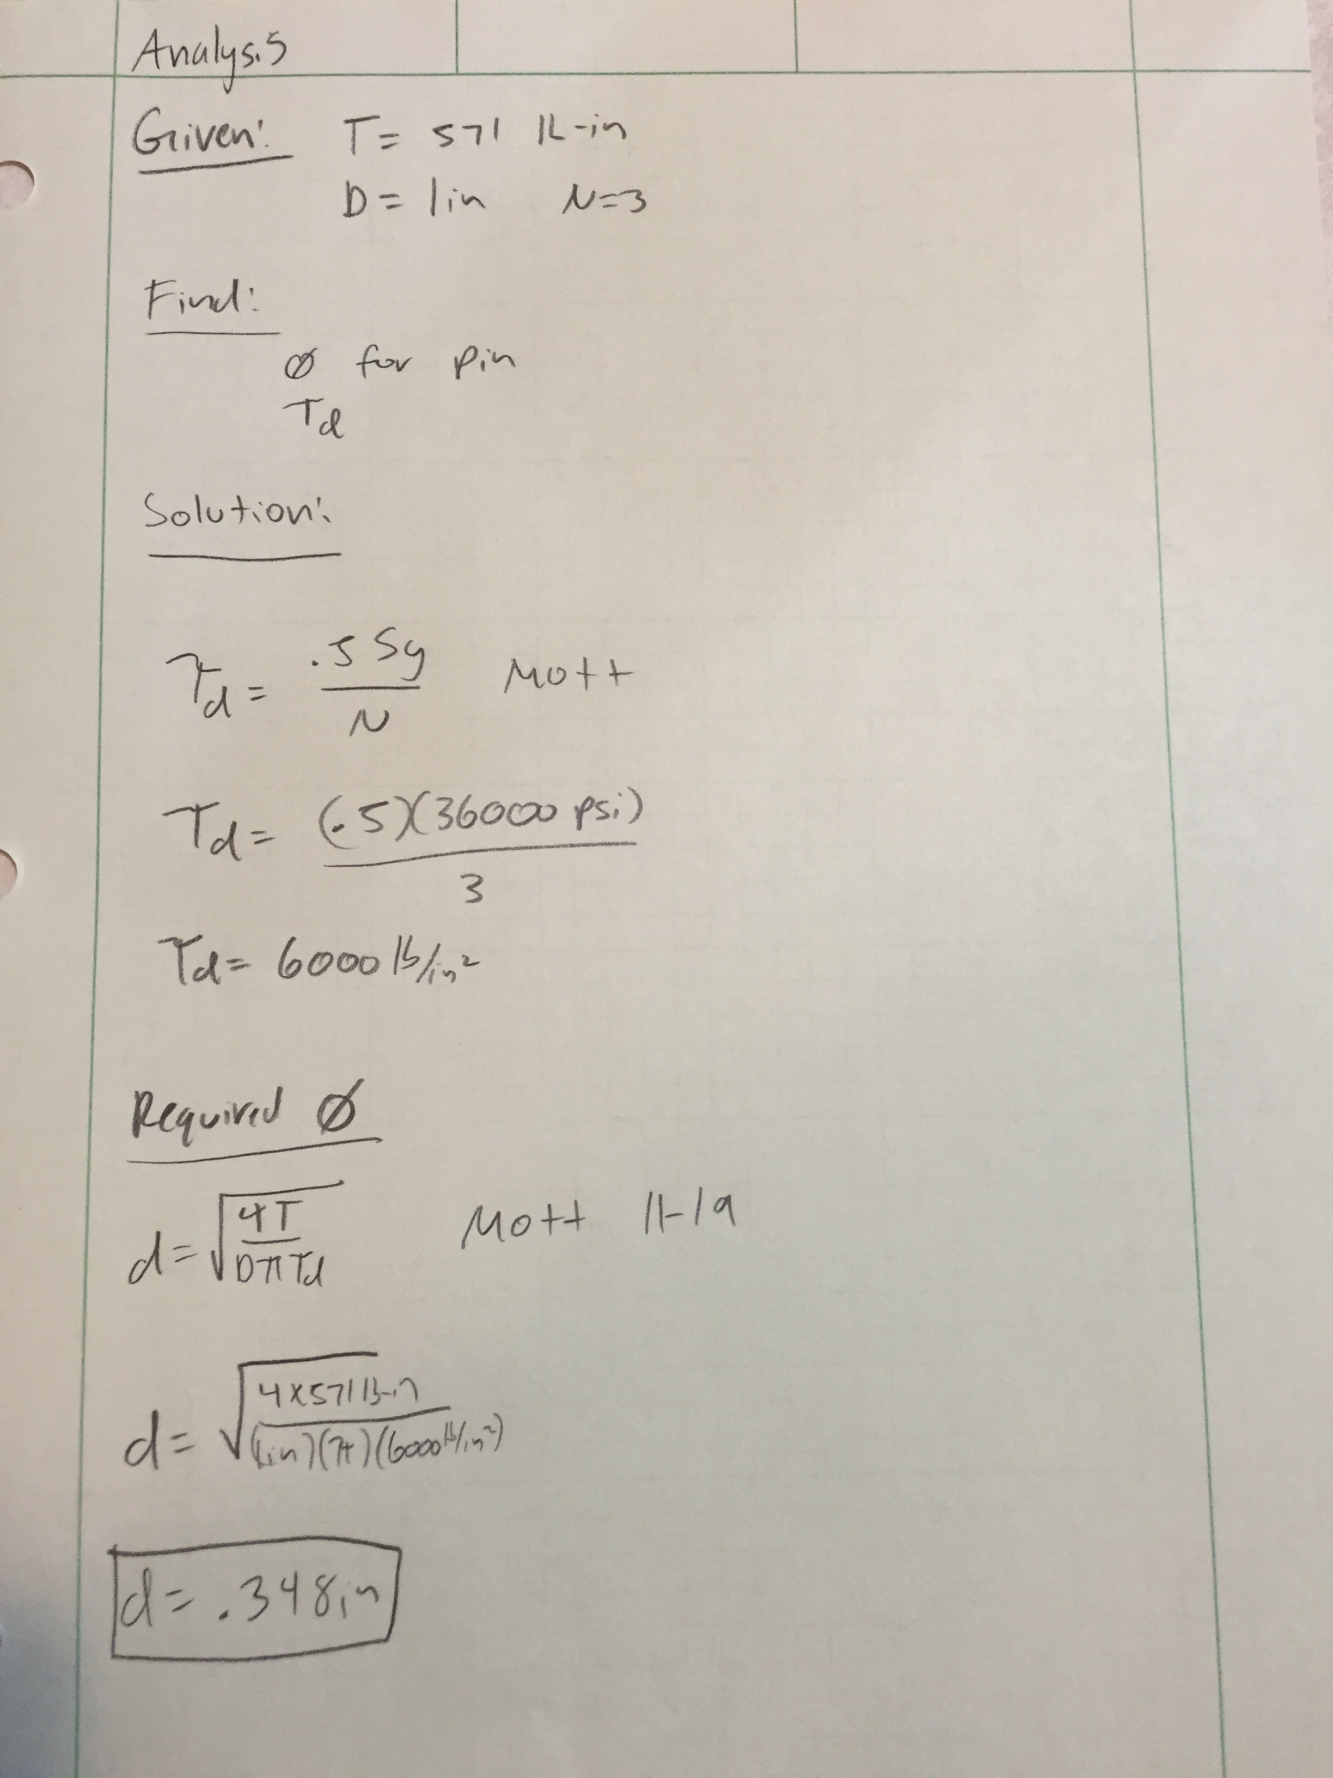

Based off the calculated torque, a minimum diameter of .348 in will be needed to connect the housing. The bolts that will be used are .375 in and are above the minimum given the material.

A.12 Shear Stress in Shaft

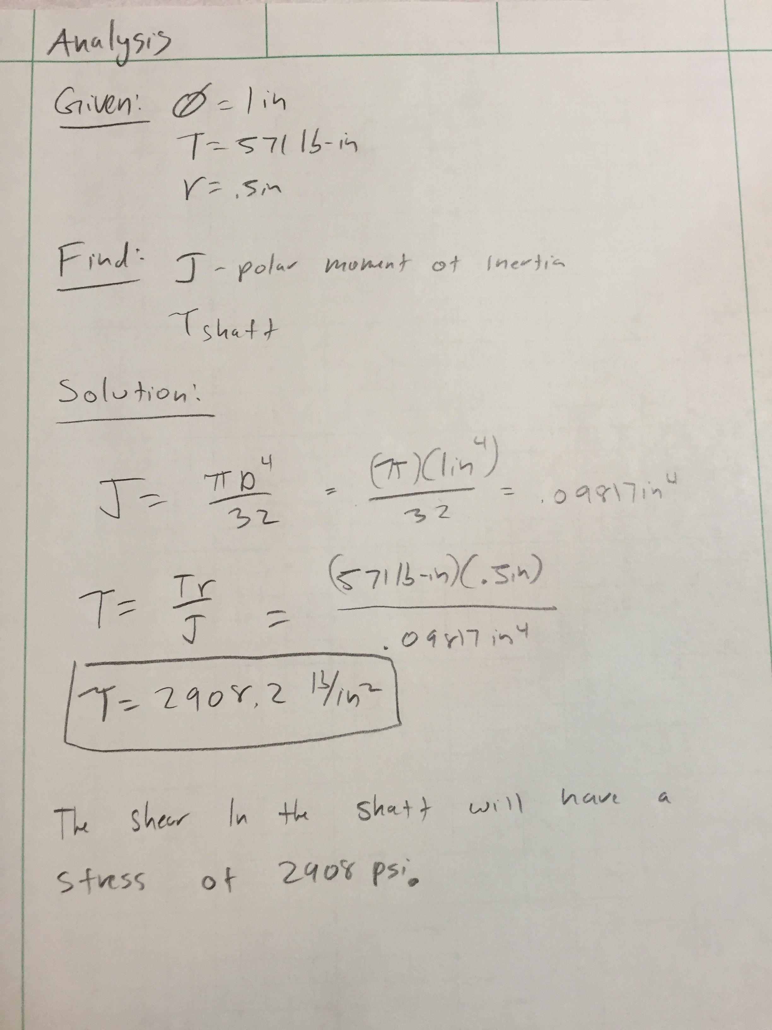
The shaft will experience a shear stress of 2908 psi. The chosen material, A36 will allow the shaft to rotate without failure.

A.13 Chain Spreadsheet Calculation

CHAIN DRIVE DESIGN
Initial Input Data: | Example Problem 7-3 - Multiple strands
Application: | Coal Conveyor
Drive type: | Engine-Mechanical drive
Driven machine | Heavily loaded conveyor
Power input: | 5 | hp
Service factor: | 1.5 |  | Table 7-8
Input speed: | 1750 | rpm
Desired output speed: | 600 | rpm
Computed Data:
Design power: | 7.5 | hp
Speed ratio: | 2.92
Design Decisions-Chain Type and Teeth Numbers:
Number of strands: | 1 |  | 1 2 3 4
Strand factor: | 1.0 |  | 1.0 1.7 2.5 3.3
Required power per strand: | 7.50 | hp
Chain number: | 40 |  | Tables 7-5, 7-6, or 7-7
Chain pitch: | 0.5 | in
Nunber of teeth-Driver sprocket: | 14
Computed no. of teeth-Driven sprocket: | 40.83
Enter: Chosen number of teeth: | 44 |  | Check availability from vendor
Computed Data:
Actual output speed: | 556.8 | rpm
Pitch diameter-Driver sprocket: | 2.247 | in
Pitch diameter-Driven sprocket: | 7.009 | in
Center Distance, Chain Length and Angle of Wrap:
Enter: Nominal center distance: | 30 | pitches | 30 to 50 pitches recommended
Computed nominal chain length: | 89.8 | pitches
Enter: Specified no. of pitches: | 110 | pitches | Even number recommended
Actual chain length: | 55.00 | in
Computed actual center distance: | 40.217 | pitches
Actual center distance: | 20.108 | in
Angle of wrap-Driver sprocket: | 166.4 | degrees | Should be greater than 120 degrees
Angle of wrap-Driven sprocket: | 193.6 | degrees
The original plan of using a system of gears to reduce the RPM from 1750 to around 600 had to be changed. The reasoning of the change was that finding gears with the number of teeth and pitch diameters proved to be a problem. One way that this could have been fixed was if custom gears were made that would produce a 3:1 reduction. A quote from rushgears.com came out to be an excess of $1000.00 which was not possible. Material would have to been ordered and carful machining would have to be done to produce the desired results. To bypass the machining of new gears, a chain and sprocket was used. Using the spreadsheets provided by Professor Pringle, a 2.92 speed reduction was attained, and sprockets ordered from McMaster Carr.

A.14 Gear Spreadsheet Calculation

DESIGN OF SPUR GEARS |  |  | APPLICATION:
Initial Input Data:
Input Power: | P = | 7.5 | hp
Input Speed: | n_{P} = | 600 | rpm
Diametral Pitch: | P_{d} = | 8
Number of Pinion Teeth: | N_{P} = | 20
Desired Output Speed: | n_{G} = | 600 | rpm
Computed number of gear teeth: |  | 20.0
Enter: Chosen No. of Gear Teeth: | N_{G} = | 20
Computed data:
Actual Output Speed: | n_{G} = | 600.0 | rpm
Gear Ratio: | m_{G} = | 1.00
Pitch Diameter - Pinion: | D_{P} = | 2.500 | in
Pitch Diameter - Gear: | D_{G} = | 2.500 | in
Center Distance: | C = | 2.500 | in
Pitch Line Speed: | v_{t} = | 393 | ft/min
Transmitted Load: | W_{t} = | 630 | lb
Secondary Input Data:
 | Min | Nom | Max
Face Width Guidelines (in): | 1.000 | 1.500 | 2.000
Enter: Face Width: | F = | 1.000 | in
Ratio: Face width/pinion diameter: | F/D_{P} = | 0.40
Recommended range of ratio: 0.50 < F/D_{P} < 2.00
Enter: Elastic Coefficient: | Cp = | 2300 | Table 9-10
Enter: Quality Number: | Q_{v} = | 6 | Table 9-2
Enter:Bending Geometry Factors:
Pinion: | J_{P} = | 0.325 | Fig. 9-15
Gear: | J_{G} = | 0.410 | Fig. 9-15
Enter:Pitting Geometry Factor: | I = | 0.104 | Fig. 9-21
 | REF: m_{G} = | 1.00

A.14 Gear Spreadsheet Calculation Continued

Factors in Design Analysis:
Alignment Factor, K_{m}=1.0+C_{pf}+C_{ma} | If F<1.0 | If F>1.0
Pinion Proportion Factor, C_{pf} = | 0.015 | 0.015 | [0.50 < F/D_{P} < 2.00]
Enter: C_{pf} = | 0.042 | Figure 9-16
Type of gearing: | Open | Commer. | Precision | Ex. Prec.
Mesh Alignment Factor, C_{ma} = | 0.264 | 0.143 | 0.080 | 0.048
Enter: C_{ma} = | 0.264 | Figure 9-17
Alignment Factor: K_{m} = | 1.31 | [Computed]
Overload Factor: K_{o} = | 1.75 | Table 9-6
Size Factor: K_{s} = | 1.00 | Table 9-7: Use 1.00 if P_{d} >= 5
Pinion Rim Thickness Factor: K_{BP} = | 1.00 | Fig. 9-18: Use 1.00 if solid blank
Gear Rim Thickness Factor: K_{BG} = | 1.00 | Fig. 9-18: Use 1.00 if solid blank
Dynamic Factor: K_{v} = | 1.27 | [Computed: See Fig. 9-19]
Service Factor: SF = | 1.00 | Use 1.00 if no unusual conditions
Hardness Ratio Factor: C_{H} = | 1.00 | Fig. 9-23 or 9-24; Gear only
Reliability Factor: K_{R} = | 1.00 | Table 9-9 | Use 1.00 for R = .99
Enter: Design Life: | 3000 | hours | See Table 9-8
Pinion - Number of load cycles: N_{P} = | 1.1E+08 | Guidelines: Y_{N}, Z_{N}
Gear - Number of load cycles: N_{G} = | 1.1E+08 | 10⁷ cycles | >10⁷ | <10⁷
Bending Stress Cycle Factor: Y_{NP} = | 0.96 | 1.00 | 0.98 | Fig. 9-20
Bending Stress Cycle Factor: Y_{NG} = | 0.98 | 1.00 | 0.98 | Fig. 9-20
Pitting Stress Cycle Factor: Z_{NP} = | 0.92 | 1.00 | 0.95 | Fig. 9-22
Pitting Stress Cycle Factor: Z_{NG} = | 0.95 | 1.00 | 0.95 | Fig. 9-22
Stress Analysis: Bending
Pinion: Required s_{at} = | 46,793 | psi | See Fig. 9-8 or
Gear: Required s_{at} = | 36,335 | psi | Table 9-3 or 9-4
Stress Analysis: Pitting
Pinion: Required s_{ac} = | 209,449 | psi | See Fig. 9-9 or
Gear: Required s_{ac} = | 202,835 | psi | Table 9-3 or 9-4
Specify materials, alloy and heat treatment, for most severe requirement.
One possible material specification:
Pinion requires HB 320: AISI 4140 OQT 1000; HB 341, 18% Elongation
Gear requires HB 310: AISI 4140 OQT 1100; HB 311, 20% Elongation

Using the information attained in the previous calculation, multiple iterations were done using this gear calculation spreadsheet provided by Professor Pringle. This spreadsheet provided a convenient way to find the proper gear. But since not all gears were available on McMaster Carr, iterations were done until a set of gears were found that would work but were also readily available for purchase. The final gear had a pitch diameter of 2.5 in and a total of 20 teeth. This proved to be the most critical dimension needed when constructing the device. Since the center to center distance was calculated to be 2.5 in, it was important that it was met.

APPENDIX B – Sketches, Assembly drawings, Sub-assembly drawings, Part drawings

Assembly.1 First Version of Assembly

B.1 Drawing Tree

Top Plate
2 Mating plates
2 Side plates
Housing
2 Set screw for key
Fasteners
Blades
Motor Gear
Mating Motor Shaft

Coupling
Gear Box
Motor
()
Final Cutter Assembly

Cutting Shafts

Bearings
Bearings

8 Bolts

B.2 Electric Motor

The provided electric motor drawings was provided from McMaster Carr. The base mount AC motor has a maximum RPM of 1750, and a power of 5 HP. There are also holes drilled so that the motor can be mounted to another component that will stop it from moving when in operation. The motor output shaft has a key way, which will be used to house the sprocket.

B.3 Chain

The chain that was used to spec the sprockets was a ANSI 40 chain. The chain has been assembled to the calculated total length of 55 in. 5 ft total length of chain was purchased.

B.3 Connecting link for Chain

This is the connecting link that is required for the chain to work.

B.4 Shaft for Blades

These are the shafts that will have the blades mounted and fastened on. The key is necessary so that the shaft will be able to mate the gears that have been chosen to transmit torque. The minimum diameter requirement is met and exceeded so that all components will fit. The key will either have to be machined on or inserted depending on availability of material and if it’s possible to machine.

B.5 Sprocket Small

This is the smaller of the sprockets. This sprocket will be directly attached to the motor purchased and fastened through a key.

B.6 Key

The key provided is based off the key way that is provided in the coupling. This material will be readily available from a previous employer or from scrap from the saw cuts.

B.7 Cover Plate 2

This is the plate that will house the cutting shafts. It will be the last part assembled. There will be 3/8” holes drilled in the bottom of the plate so that it can be fastened. The distance between the holes are based off the position of the shafts and their calculated diameters.

B.8 Gear 1

Upon competition of a gear calculation using a spreadsheet provided by Professor Pringle, this gear was found and was available on McMasters Carr. This gear was purchased and assembled onto the device. There are two of these gears total on the assembly.

B.9 Top Plate – ASME Y14.5

A revision needed to make the hole larger than originally thought. The width of the material once delaminated is still not certain, so the width of the hole is subject to change. The offset of the gap is due to the gears are housed inside of the housing. The critical dimension on this part is the length of the hole so that material will be able to fit. The width may have to altered because it is still not known the exact width the material will be once it has gone through the delamination device.

B.10 Sample Blade

This blade has been used as a place holder. After receiving a recommendation from Boeing, the blade that will be used can be found on this website.
URL: www.mscdirect.com/product/details/73323081

B.11 Sprocket 1

This is the larger sprocket that will be attached to one of the shafts. One of the shafts has a keyway that is continuous due to the fact that the sprocket needs to be connected to it by way of a key.

B.12 Side Plate

B.13 Bolts

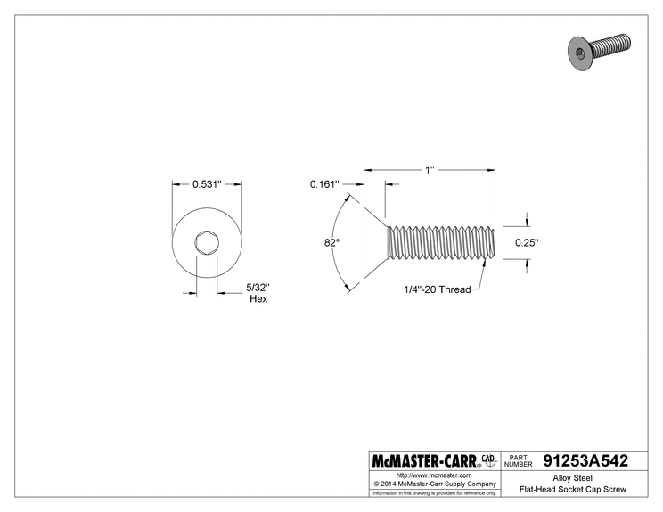

B.14 Bearing
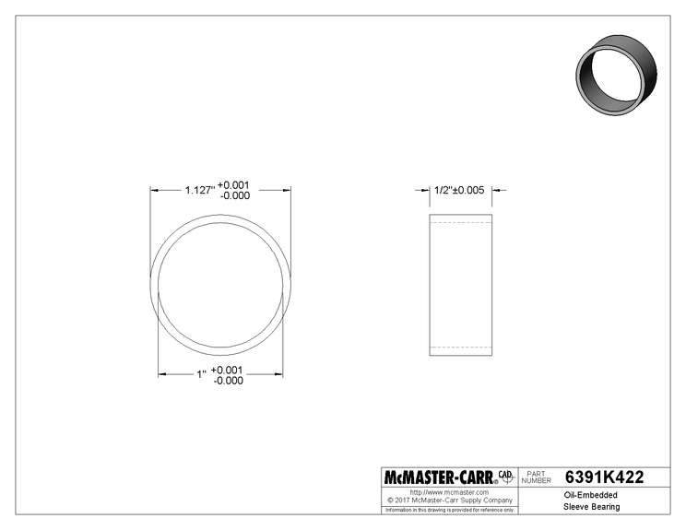

These bearings were purchased and press fit in both the side and front plates of the housing.

B.15 Keyway 2

APPENDIX C – Parts List and Costs

Part Ident | Part Description | Source | Cost | Disposition
Steel | 1’ stick 2” round (2) | Metal Shorts  Seattle WA | $60.00 | TBD
Steel | 8” cylinders 1” thick (2) | Metal Shorts | $80.00 | TBD
Motor | 10 HP  6136K512 | McMaster Carr  #11-111111-1 | $654.44 | TBD
Steel | 6”x6”x6” block | Metal Shorts | $250.00 | TBD
Heat Treating | HT of individual parts | Seattle Heat Treaters | TBD | TBD
Coupler | 1 1/8in key  61005K177 | McMaster-Carr | $77.71 | TBD
Machining Exp | Former Employer | Wright Machine | $80/hr | TBD
Bolts | 3/8 in | McMaster-Carr | $11.21/25 | TBD
Gear 1 | 6 in pitch 18 teeth  6867K4 | McMaster-Carr | $118.41 | TBD
Gear 2 | 6 in pitch 12 teeth  6867K98 | McMaster-Carr | $86.09(2) | TBD
Side Plates | A36 9in x 9 in | Metal Shorts  Seattle WA | $80.00 | TBD
Base Plate | 36 in x 9 in | Metal Shorts  Seattle WA | $150.00 | TBD

Current total estimated cost is $1567.86

APPENDIX D – Budget

The current estimated cost was calculated to be $1567.86. Thanks to a grant that Dr. Johnson was able to secure, the cost will not be an issue. More fine tuning of the machine must be done so that money is not wasted on a not realistic solution. The supplier of metal that a former employer went to was the first supplier that came to mind (Metal Shorts). A reason that A36 steel is being used for many of the parts of the assembly is that Wright Machine deals with a lot of steel, and could possibly donate some for this project. So the final cost is subject to change once a list of materials is ordered. Some might be donated which will bring the cost down.

APPENDIX E – Schedule

Gantt Chart
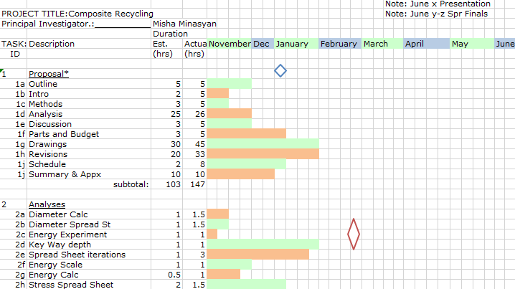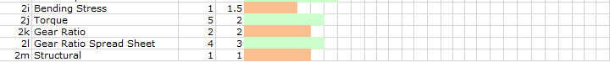
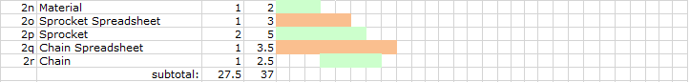
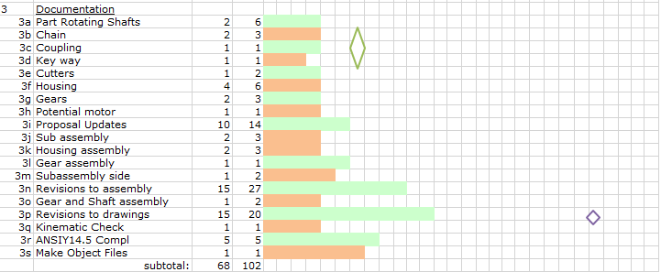
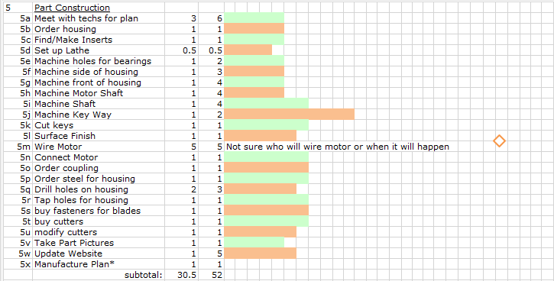
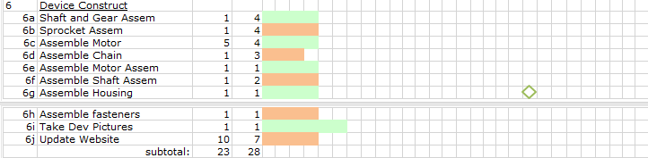

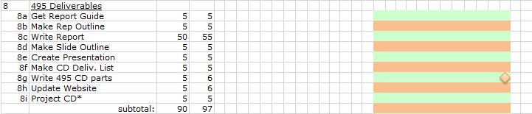

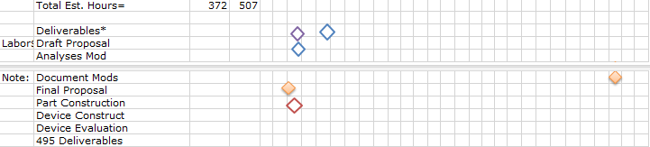

Gantt Chart Description

Note: March x Finals
Note: June x Presentation

Appendix F – Expertise and Resources
John Locklear
Email : john.c.lockleer@boeing.com

APPENDIX G – Evaluation sheet (Testing)
Insert Spring

APPENDIX H – Testing Report
Insert Spring

APPENDIX I – Testing Data
Insert Spring

Appendix J – Resume

Mikhail K. Minasyan
2204 N 105th St APT F-105
Seattle, WA, 98133, United States
(206)-853-1625
minasyanm@cwu.edu
Professional Experience
Wright Machine
Designer/CNC operator: June 2015 – September 2017
• Deliver completed projects.
• Operate lathes, mills, sanders and drills.
• Assist on graphic designs, lead solid works designer.
• Help engineer solutions for various customers.
• Do invoices and keep financials in check.
• Compute and record totals of transactions.
JcPenney Seattle, WA
Cashier: January 2012 - April 2012
• Receive payment by cash, check, credit cards, vouchers, or automatic debits.
• Issue receipts, refunds, credits, or change due to customers.
• Answer customers' questions, and provide information on procedures or policies.
• Count money in cash drawers at the beginning of shifts to ensure that amounts are correct and that there is adequate change.
• Calculate total payments received during a time period, and reconcile this with total sales.
• Monitor checkout stations to ensure that they have adequate cash available and that they are staffed appropriately.
• Compute and record totals of transactions.
Education
Shorewood High school Shoreline, WA
• Graduated with 3.5 GPA
Central washington university , WA
Mechanical Engineering Technology Student, June 2018 expected graduation
• Also took Accounting 201, and Computers for Business 169, PLC experience, Can speak fluent Russian
Additional Skills
• Microsoft Word, Access, Excel and Powerpoint
• Customer Service
• Money Handling and Transactions, Upper level Mathematics
• Recommending Services for Customers
• Social Skills,
• Organization

References
Max Zimmerman- (206) 305-0642
Jorge Landa-(206) 910-1186

